

**(CT133-3-2-SRE)**

**SWITCHING AND ROUTING ESSENTIALS**

**GROUP ASSIGNMENT**

**INTAKE CODE : APU2F2502CS(CYB)**

**LECTURER : Joshua Samual**

**HAND OUT DATE : 21 March 2025**

**HAND IN DATE : 6 June 2025**

**GROUP : BungkusSRE**

|  |  |
| --- | --- |
| **Student ID** | **Student Name** |
| TP080121 | YAW KAI YUAN |
| TP081340 | LEE YI CHERN |
| TP080482 | HO KUN YUN |
| TP079000 | LIM HAO ZHEN |
| TP080509 | VOON YUE CHENG |
| TP080429 | VOON WEI SIANG |
| TP079795 | CHONG CHIA ZHI |

Table of Contents

1.0 Introduction 4

2.0 Network Topology Diagram 5

3.0 IP Addressing Table 6

3.1 HQ - KL 6

3.2 Remote Branch – Singapore (SG) 6

3.3 Remote Branch – Australia (AUS) 7

3.4 WAN 8

4.0 LAN and WAN Configuration – Lee Yi Chern TP081340 9

4.1 LAN 9

4.1.1 KL 9

4.1.2 SG 18

4.1.3 AUS 25

4.2 WAN 35

5.0 WLAN Architecture (AUS) – Yaw Kai Yuan TP080121 39

6.0 EtherChannel Implementation (KL) – Voon Wei Siang TP080429 60

7.0 HSRP Implementation – Ho Kun Yun TP080482 65

7.1 KL 65

7.1.1 Router 1 65

7.1.2 Router 2 67

7.2 AUS 69

7.2.1 Router 1 69

7.2.2 Router 2 71

8.0 Server Farm Configuration (SG) – Chong Chia Zhi TP079795 74

9.0 Evidence of a successful ping of the network interconnect 79

10.0 Security Mechanisms Deployment – Lim Hao Zhen TP079000 83

10.1 Port Security 83

10.1.1 KL 83

10.1.2 AUS 86

10.1.3 SG 87

10.2 DHCP Snooping 89

10.2.1 AUS 89

10.3 Dynamic ARP Inspection (DAI) 91

10.3.1 KL 91

10.3.2 AUS 94

10.4 PortFast/BPDU Guard 95

10.5 Overall Summary 98

11.0 Recommendation for improving security mechanisms - Voon Yue Cheng TP080509 99

12.0 Conclusion 100

13.0 References 101

# 1.0 Introduction

In today’s fast-evolving networking environment, organizations must design and implement a secure, flexible, and scalable network to support their business growth and carry out their operations efficiently. This report presents the design of a prototype of a new network for Cloud Co. Cloud Co is a multinational company that has a headquarters located in Kuala Lumpur (KL) and two remote branches located in Australia (Aus) and Singapore (SG). The network’s logical topology and configuration of the devices will be done using Cisco Packet Tracer.

There are some key requirements that must be considered while designing the network topology, including the configuration of a WLC WLAN to use a VLAN interface, a DHCP server, and WPA2 authentication for Australia network. The network incorporates IPv4 addressing using static and dynamic routing by implementing OSPF and default static route, implementation of port security to mitigate layer 2 attacks, and implementation of HSRP and EtherChannel for redundancy and load balance. Additionally, the setup includes cconfiguration of basic switch and router, and implementation of server farm for FTP, DNS, and Web Server services.

This report outlines the details and steps of the network topology planning, IP addressing and configurations for the devices, providing a comprehensive guide to set up a secure and efficient network.

# 2.0 Network Topology Diagram

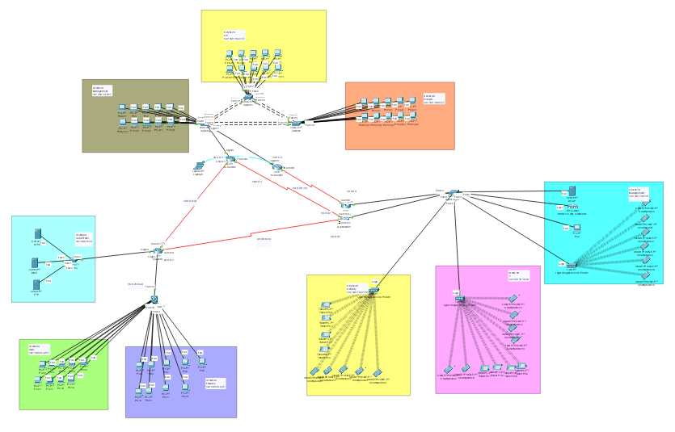

# 3.0 IP Addressing Table

## 3.1 HQ - KL

|  |  |  |  |  |  |  |
| --- | --- | --- | --- | --- | --- | --- |
| Site | Department | Network Address | Default Gateway | Subnet | Broadcast  Address | Subnet Mask |
| KL | Management (VLAN 10) | 192.168.10.0 | 192.168.10.1 | 192.168.10.0/27 | 192.168.10.31 | 255.255.255.224 |
| HR  (VLAN 20) | 192.168.10.32 | 192.168.10.33 | 192.168.10.32/27 | 192.168.10.63 | 255.255.255.224 |
| Design  (VLAN 30) | 192.168.10.64 | 192.168.10.65 | 192.168.10.64/27 | 192.168.10.95 | 255.255.255.224 |

## 3.2 Remote Branch – Singapore (SG)

|  |  |  |  |  |  |  |
| --- | --- | --- | --- | --- | --- | --- |
| Site | Department | Network Address | Default Gateway | Subnet | Broadcast  Address | Subnet Mask |
| SG | Finance (VLAN 40) | 192.168.20.0 | 192.168.20.1 | 192.168.20.0/27 | 192.168.20.31 | 255.255.255.224 |
| R&D  (VLAN 50) | 192.168.20.32 | 192.168.20.33 | 192.168.20.32/27 | 192.168.20.63 | 255.255.255.224 |
| Server Farm  (VLAN 60) | 192.60.0.0 | 192.60.0.1 | 192.60.0.0/29 | 192.60.0.7 | 255.255.255.248 |

## 3.3 Remote Branch – Australia (AUS)

|  |  |  |  |  |  |  |
| --- | --- | --- | --- | --- | --- | --- |
| Site | Department | Network Address | Default Gateway | Subnet | Broadcast  Address | Subnet Mask |
| AUS | Management (VLAN 70) | 192.168.70.0 | 192.168.70.1 | 192.168.70.0/28 | 192.168.70.15 | 255.255.255.240 |
| IT  (VLAN 80) | 192.168.70.16 | 192.168.70.17 | 192.168.70.16/28 | 192.168.70.31 | 255.255.255.240 |
| Delivery  (VLAN 90) | 192.168.70.32 | 192.168.70.33 | 192.168.70.32/28 | 192.168.70.47 | 255.255.255.240 |

## 3.4 WAN

|  |  |  |  |  |  |  |
| --- | --- | --- | --- | --- | --- | --- |
| Device | Interface | Network Address | Default Gateway | Subnet | Broadcast  Address | Subnet Mask |
| KLR1 | S0/0/0 | 10.0.0.0 | 10.0.0.2 | 10.0.0.0/29 | 10.0.0.7 | 255.255.255.248 |
| KLR1 | S0/0/1 | 20.0.0.0 | 20.0.0.1 | 20.0.0.0/29 | 20.0.0.7 | 255.255.255.248 |
| KLR2 | S0/0/0 | 10.0.0.0 | 10.0.0.4 | 10.0.0.0/29 | 10.0.0.7 | 255.255.255.248 |
| AUSR1 | S0/0/0 | 10.0.0.0 | 10.0.0.1 | 10.0.0.0/29 | 10.0.0.7 | 255.255.255.248 |
| AUSR1 | S0/0/1 | 30.0.0.0 | 30.0.0.2 | 30.0.0.0/29 | 30.0.0.7 | 255.255.255.248 |
| AUSR2 | S0/0/0 | 10.0.0.0 | 10.0.0.3 | 10.0.0.0/29 | 10.0.0.7 | 255.255.255.248 |
| SGR1 | S0/0/0 | 30.0.0.0 | 30.0.0.1 | 30.0.0.0/29 | 30.0.0.7 | 255.255.255.248 |
| SGR1 | S0/0/1 | 20.0.0.0 | 20.0.0.2 | 20.0.0.0/29 | 20.0.0.7 | 255.255.255.248 |

# 4.0 LAN and WAN Configuration – Lee Yi Chern TP081340

## 4.1 LAN

### 4.1.1 KL

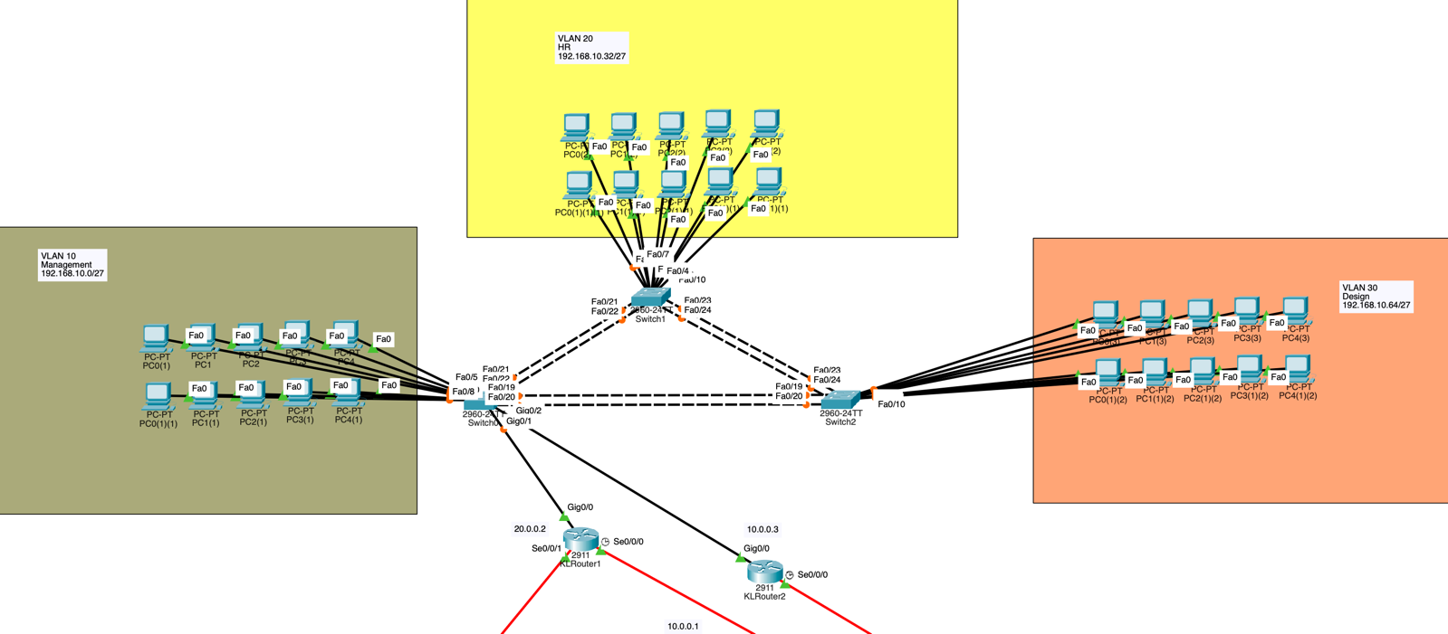

In KL, HSRP is configured for two routers (Chapter 7.1), switches are interconnected with EtherChannel (Chapter 6.0) and router-on-a-stick is implemented for VLAN routing. VLANs are assigned to Management, HR and Design department.

#### 4.1.1.1 Switch 1 (KLSW1)

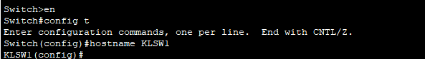

Enter privileged EXEC mode and enter global configuration mode. After that, set switch1’s hostname to KLSW1.

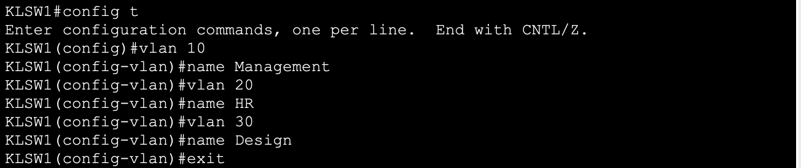

Create VLAN 10, VLAN 20 and VLAN 30, and name VLAN separately for Management, HR (Human Resource) and Design Department. Lastly, exit from VLAN configuration.



VLAN 10 Assignment

* *Int range fa0/1-18*

Select and access to the range of FastEthernet interfaces from fa0/1 to fa0/18.

* *Switchport mode access*

Set the interface of fa0/1 to fa0/18 to access mode to prepare for carry vlan 10.

* *Switchport access vlan 10*

This assigns VLAN 10 to interface of fa0/1 to fa0/18. This setup allows devices connected to the selected ports to communicate within VLAN 10 exclusively.

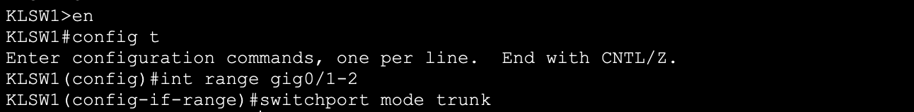

Configuring switchport gig0/1-2 that connected to KLR1 and KLR2:

* *int range gig0/1-2*

Select the range of GigabitEthernet interfaces from gig0/1 to gig0/2.

* *switchport mode trunk*

Set selected interface to trunk mode to carry traffic for trunking multiple VLANs.

Configuring basic security, local user authentication, and SSH on switch 1:

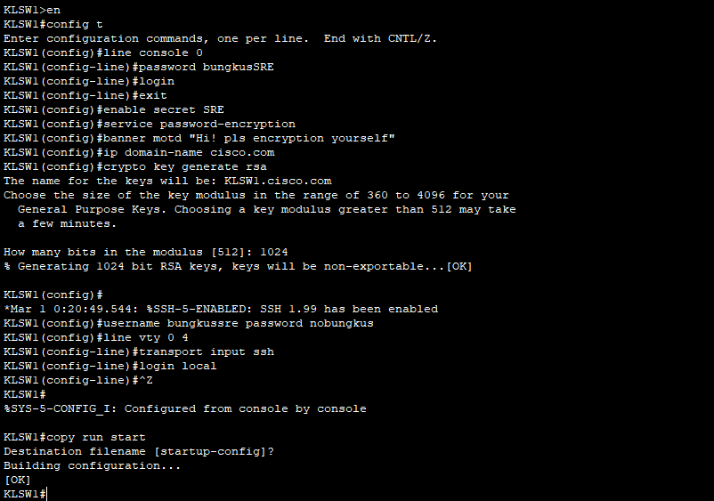

line console 0Access to console line configuration to secure physical access.

* *password bungkusSRE*

Set the console password to bungkusSRE.

* *Login*

Enable password checking for console access.

* *Exit*

Exit to global configuration mode.

* *enable secret SRE*

Set an encrypted password (SRE) for privileged EXEC access.

* *service password-encryption*

Automatically encrypts all plaintext passwords in the configuration file.

* *banner motd “HI! Pls authenticate yourself”*

Set a **message of the day banner**(motd) to display a login warning.

* *ip domain-name cisco.com*

Set the **domain name**, required for generating RSA keys.

* *crypto key generate rsa (set bit to 1024)*

To generating **RSA keys** for SSH; the admin sets the key length to **1024 bits**.

* *username bungkussre password nobungkus*

Creates a local user account named bungkussre with the password nobungkus.

* *line vty 0 4*

Accesses **virtual terminal lines 0 to 4**.

* *transport input ssh*

Restricts remote access to **SSH only**, disabling Telnet.

* *login local*

Requires **local user account authentication** (like bungkussre) for remote login.

#### 4.1.1.2 Switch 2

Same as configuring KLSW1, we create VLAN, change port mode and configure basic security for it.

Change hostname:



Create VLAN:

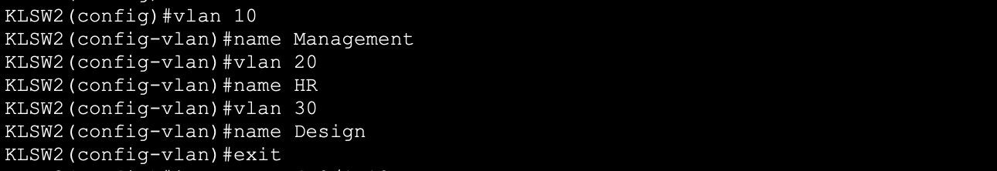

VLAN 20 Assignment:



Configure basic security, local user authentication, and SSH:

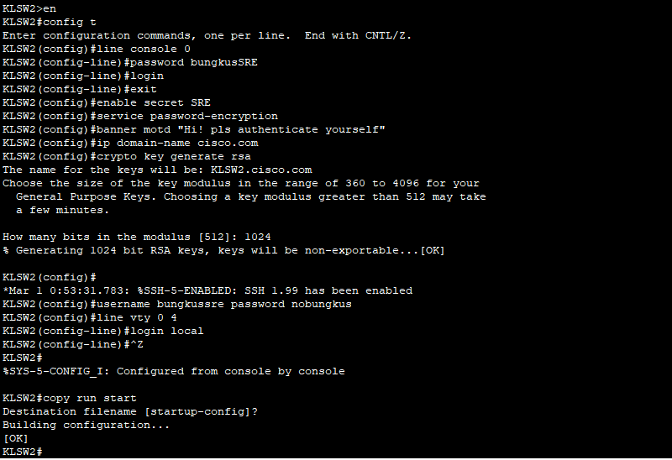

#### 4.1.1.3 Switch 3

Same as configuring KLSW1, we create VLAN, change port mode and configure basic security for it.

Change hostname:



Create VLAN:

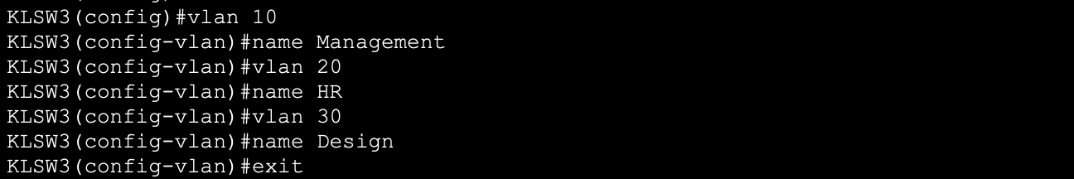

VLAN 30 Assignment:



Configure basic security, local user authentication, and SSH:

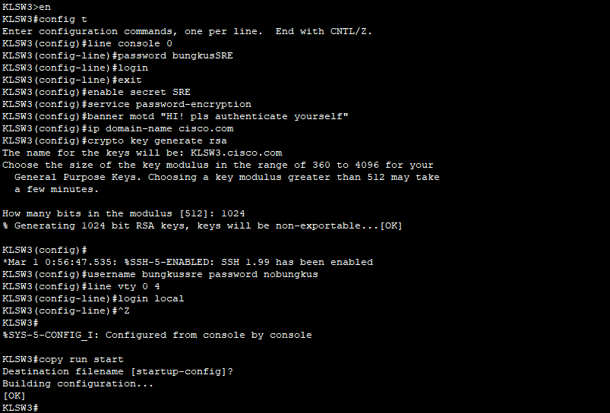

#### 4.1.1.4 Router 1

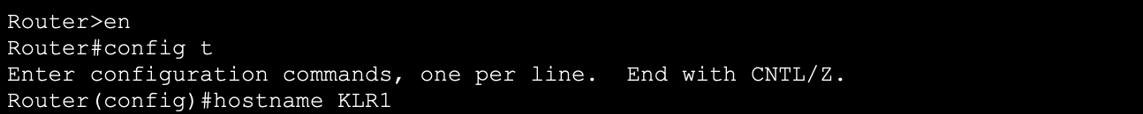

Enter privileged EXEC mode and enter global configuration mode. After that, set router1’s hostname to KLR1.

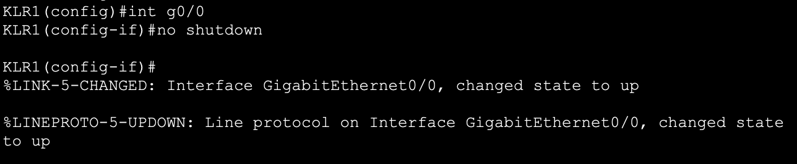

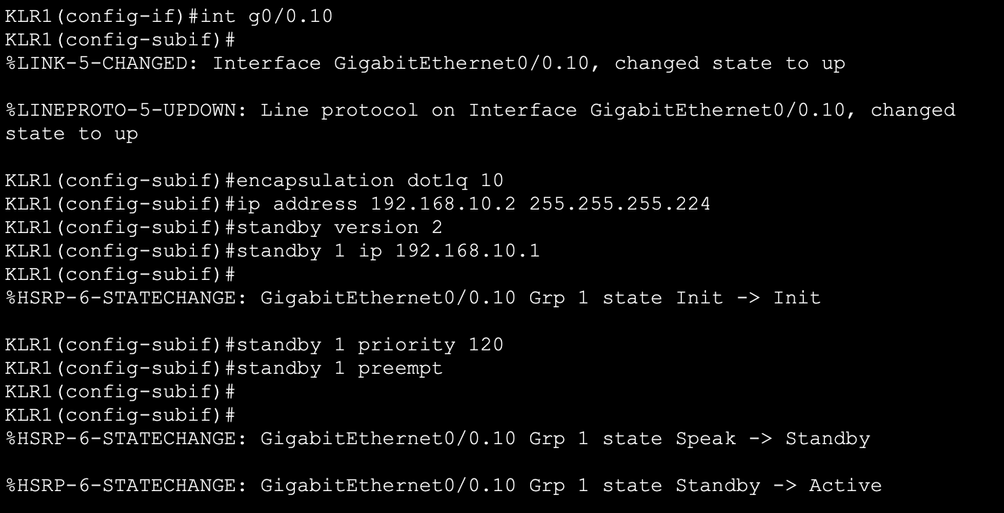

Configuring routing-on-stick on KLR1 sub interface g0/0.10:

* *int g0/0*

Access to interfaces g0/0.

* *no shutdown*

To activates the interface and ensure it will not administratively shut down.

* *int g0/0.10*

Create and access sub interface g0/0.10, which will be used for inter-VLAN routing for VLAN 10.

* *encapsulation dot1q 10*

This configures the sub interface to use 802.1Q encapsulated traffic and associate it with VLAN 10.

* *ip address 192.168.10.2 255.255.255.224*

Assigned an IP address to sub interface g0/0.10, devices (computer) in VLAN 10 will use as their default gateway.

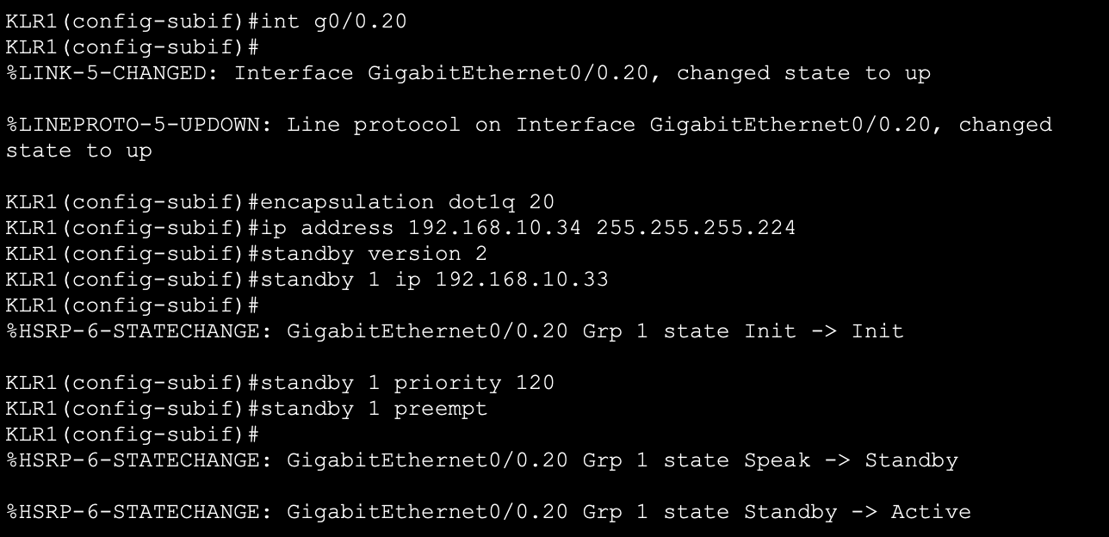

Configuring routing-on-stick on KLR1 sub interface g0/0.20

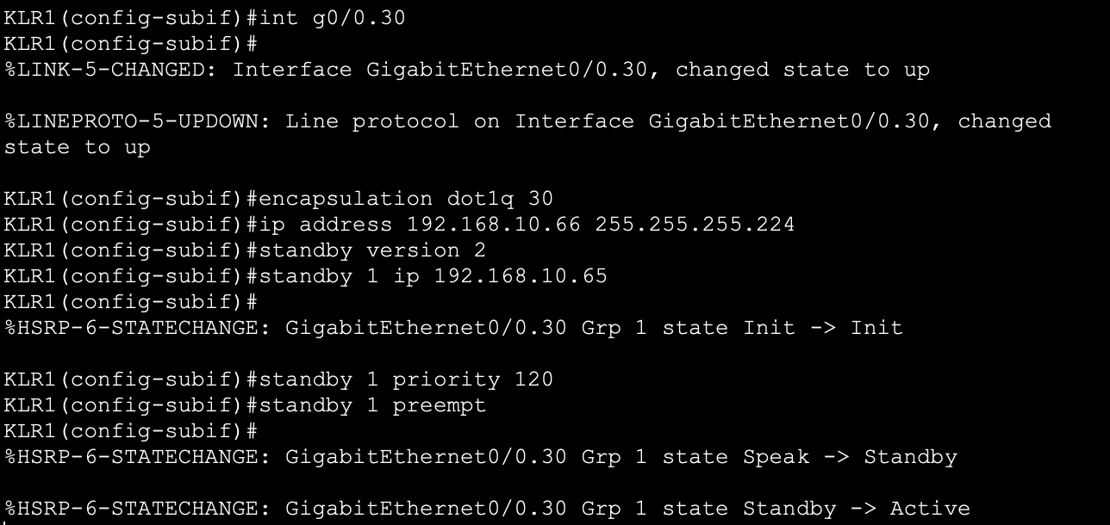

Configuring routing-on-stick on KLR1 sub interface g0/0.30

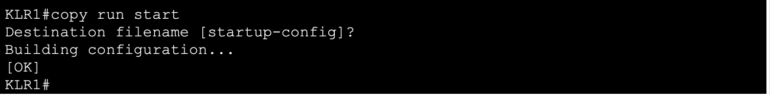

*‘copy run start’* to save the configuration.

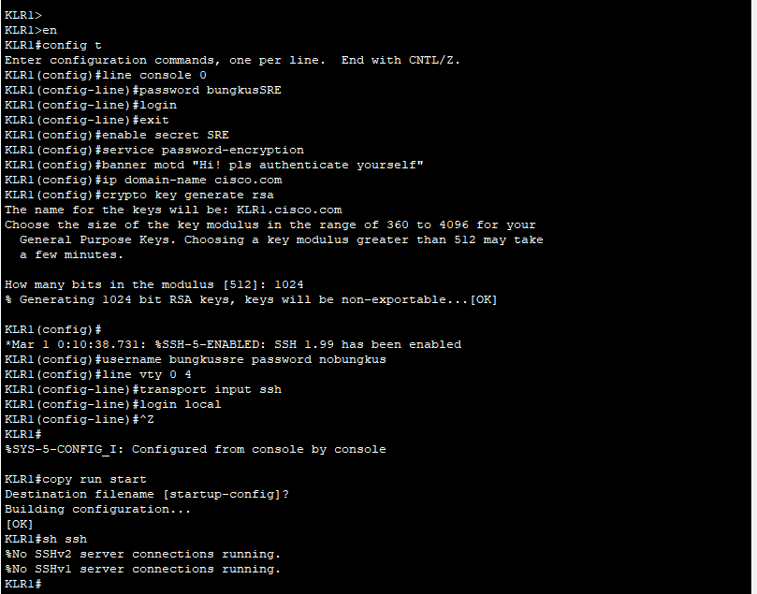

Same as Switch, configuring basic security, local user authentication, and SSH on KLR1:

#### 4.1.1.5 Router 2

Same as KLR1, we did the same configuration but just changing the ip.

Change Hostname:

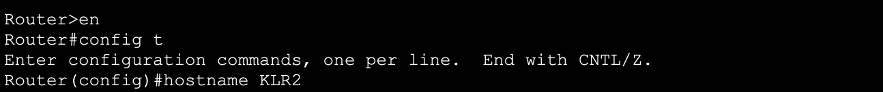

Activate port:

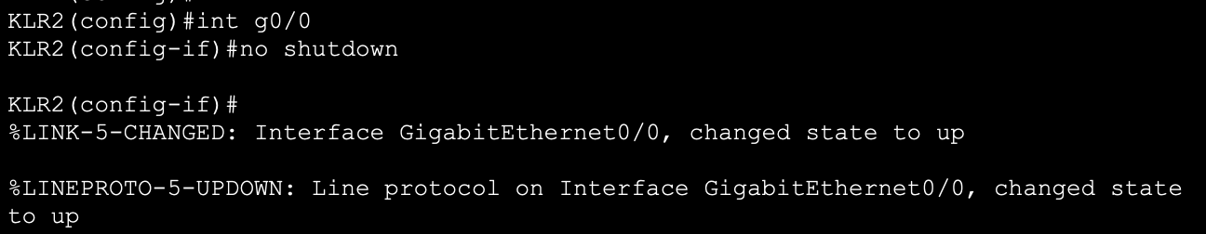

Create sub interface g0/0.10:

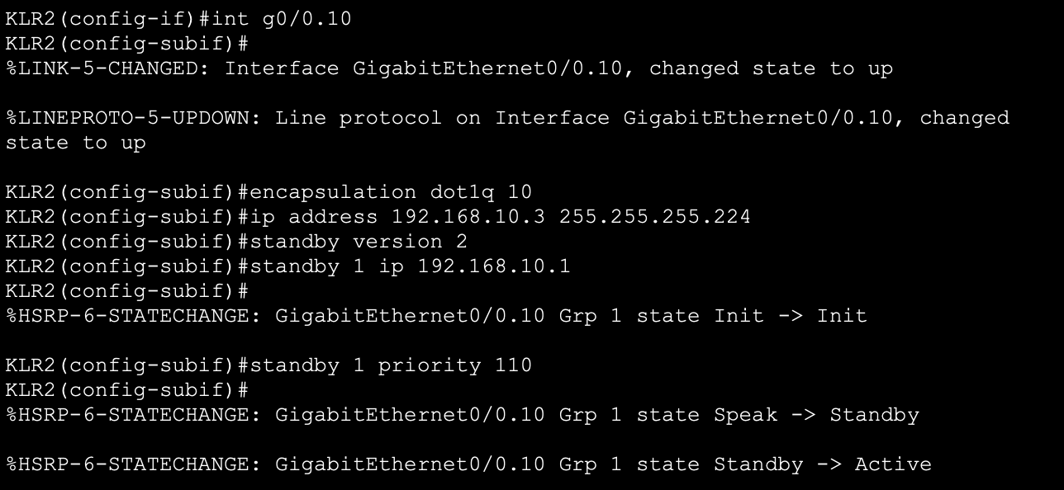

Create sub interface g0/0.20:

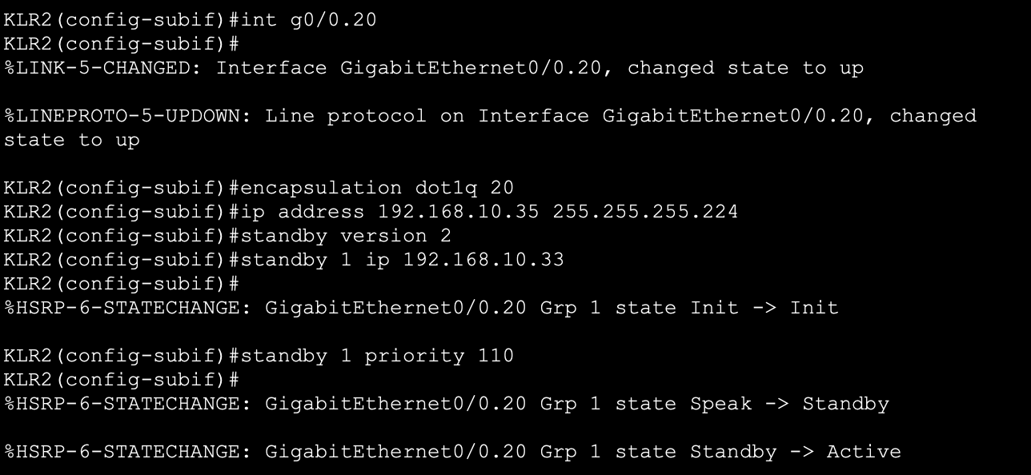

Create sub interface g0/0.10:

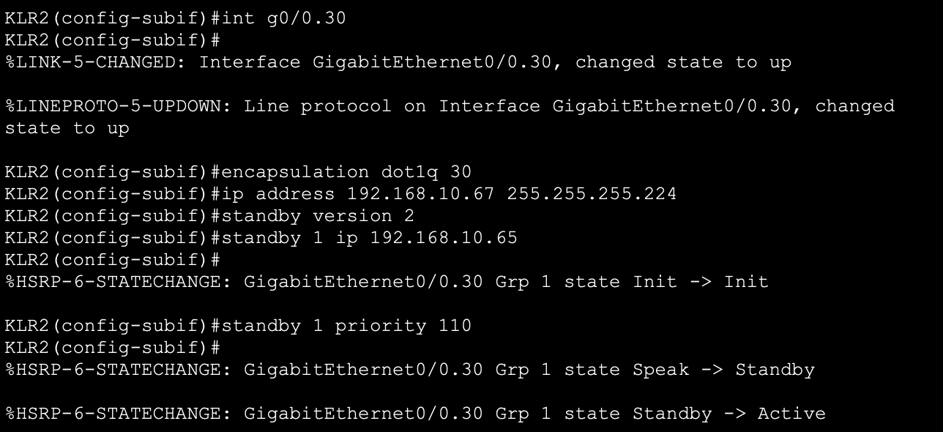

Save the configuration:

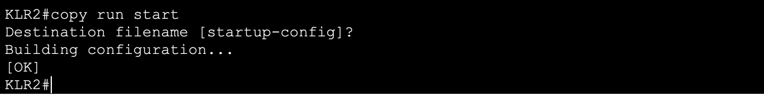

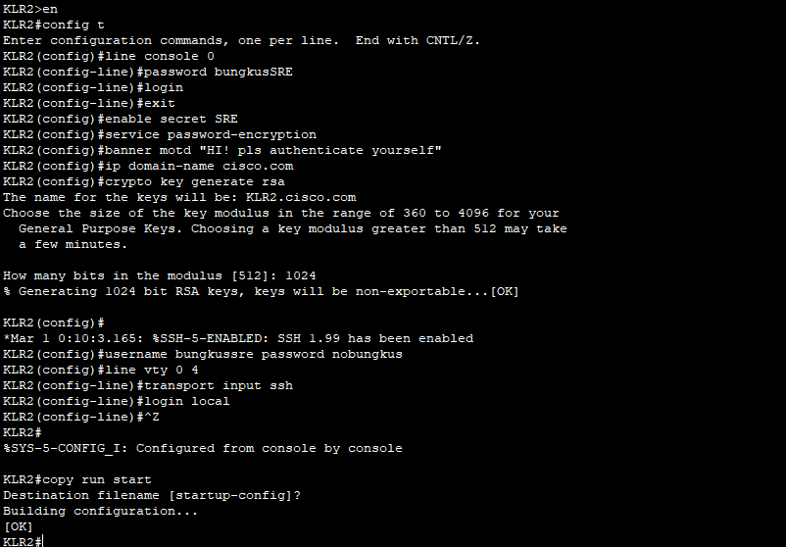

Same as Switch, configuring basic security, local user authentication, and SSH on KLR2:

### 4.1.2 SG

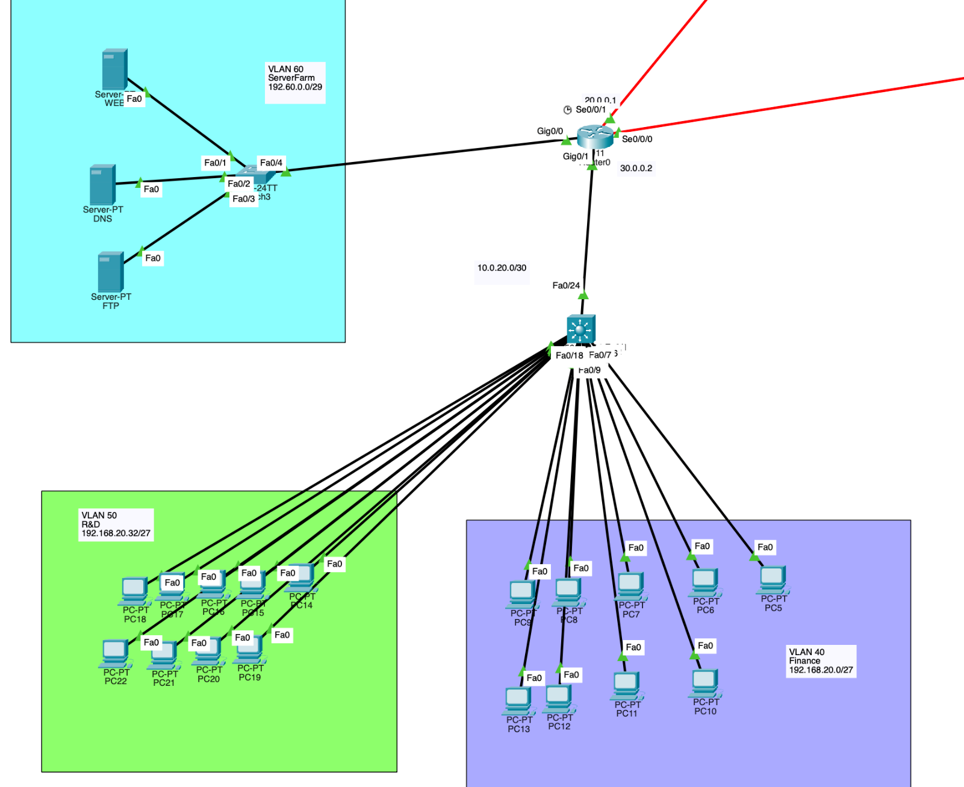

In Singapore, a Server farm is connecting with the router (Chapter 8.0). Layer 3 switch is used for inter-VLAN routing. VLANs are assigned for R&D, Finance department and Server Farm.

#### 4.1.2.1 Switch 1 (Multilayer Switch)

Enter privileged EXEC mode and enter global configuration mode. After that, set switch1’s hostname to SGSW2.

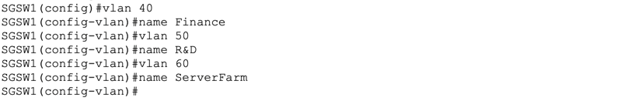Create VLAN 40, VLAN 50 and VLAN 60, and name VLAN separately for Finance, R&D and ServerFarm.

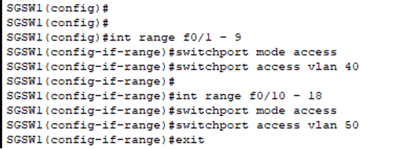

As other branches did, the port of multilayer switch is changed to access mode and assigned correspond to VLAN.

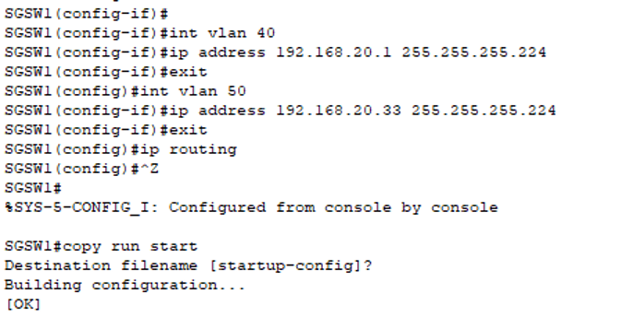

Next, ip address is assigned to each VLAN and enabling inter-VLAN routing.

* ip routing

Turns on the Layer 3 routing capability in MLS

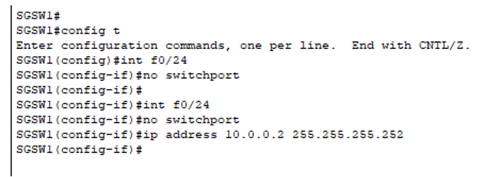

For the port, interface that connecting router should be change Layer 3 connection, which will directly route packets via this physical interface without needing VLANs. Not only that, ip are also assigned for each port.

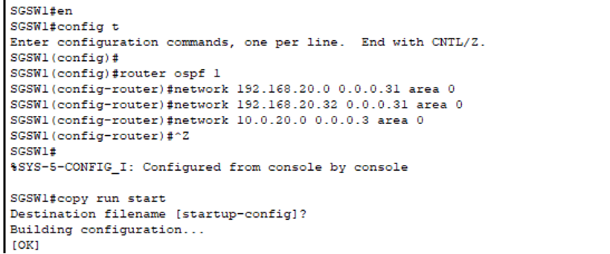

Next, OSPF is configured for the multilayer switch to allow dynamic share of routing information with other OSPF enabled devices.

* router ospf 1

Enter OSPF configuration mode with process ID 1

* network 192.168.20.0 0.0.0.31 area 0
* network 192.168.20.32 0.0.0.31 area 0
* network 10.0.20.0 0.0.0.3 area 0

Telling OSPF to include interface with the ip and wildcard into area 0

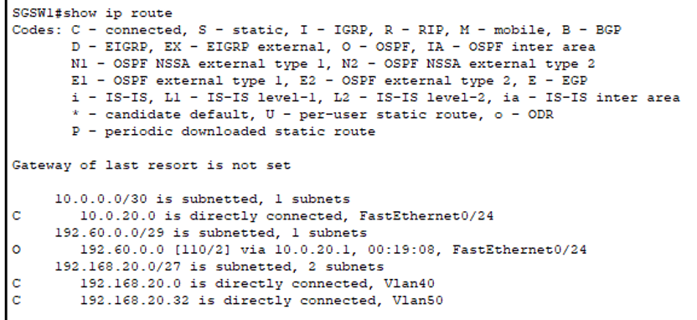

Last, verify the ip route and OSPF.

* sh ip route

Show details of ip route

* O 192.168.20.0 [110/2] via 10.0.20.1, 00:19:09, FastEthernet 0/24

O = OSPF Learned Route

O <network> [<AD>/<cost>] via <next-hop>, <age>, <interface>

Configuring basic security, local user authentication, and SSH on SGSW1:

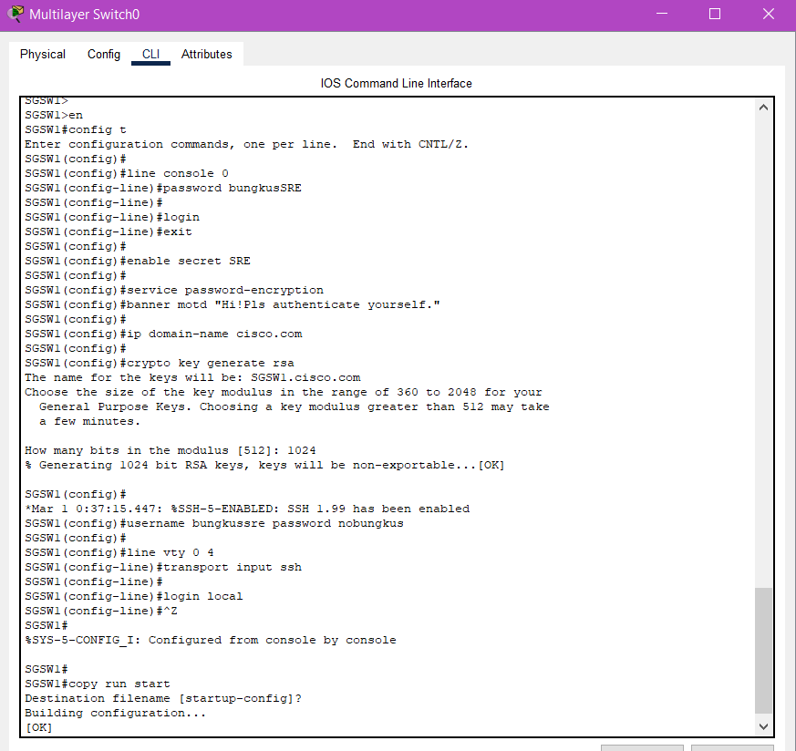

#### 4.1.2.2 Router 1

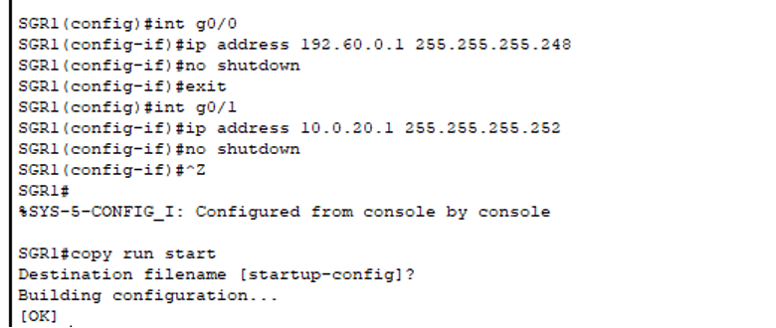

For router, ip is assigned to each of the port that connected with switches and turned on.

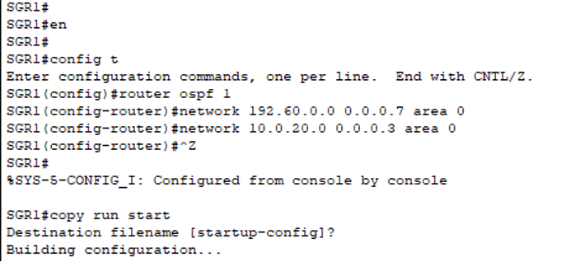

In router, OSPF configuration is configured same as the multilayer switch.

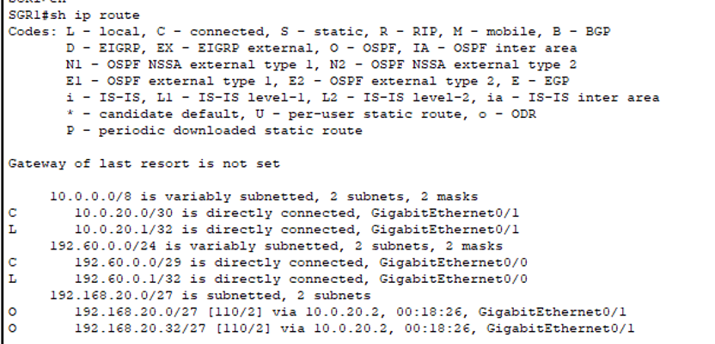

Last, verify the ip route and OSPF.

Configuring basic security, local user authentication, and SSH on SGR1:

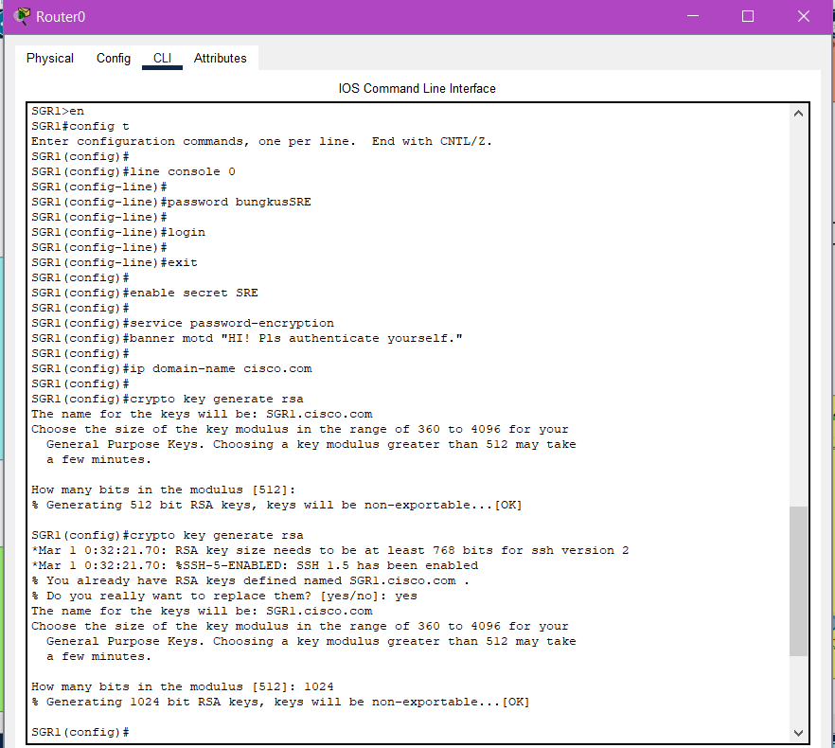

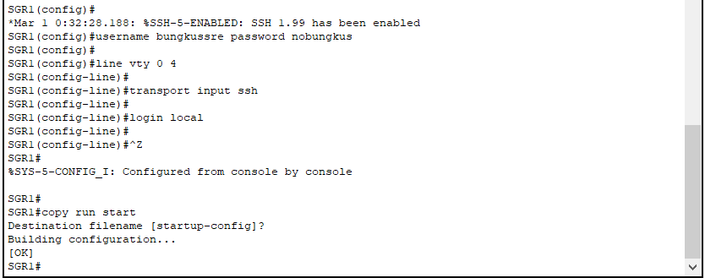

### 4.1.3 AUS

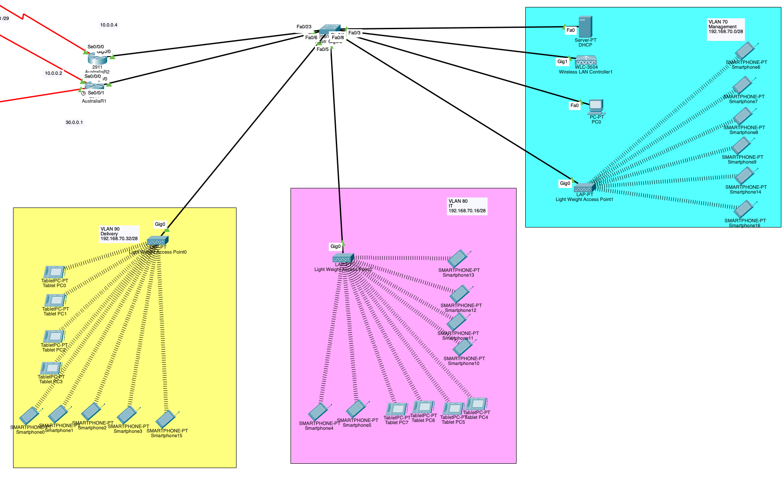

In Australia branch, wireless connectivity is managed through WLC and LAPs (Chapter 5.0). HSRP is configured for two routers (Chapter 7.1). VLANs are configured for Management, IT and Delivery department.

#### 4.1.3.1 Switch 1

We are going to configuration switch 1 and creating different VLANs for different departments in Australia.

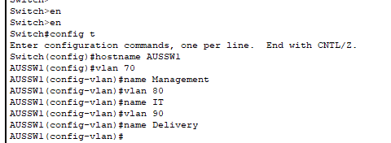

Firstly, we enter privileged EXEC mode *(en)* and global configuration mode *(config t)*. We renamed the switch name to **AUSSW1.** Then, we create VLAN 70 for Management department, VLAN 80 for IT department and VLAN 90 for Delivery department.

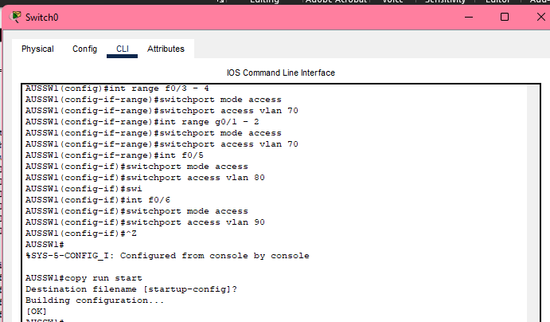

Now, we are going to assign specific FastEthernet and GigabitEthernet ports to specific VLANs:

* *int range f0/3 – 4 and int range g0/1 -2*

Select the range of FastEthernet ports from 0/3 to 0/4 and GigabitEthernet ports from 0/1 to 0/2.

* *switchport mode access*

Set the ports f0/3 and f0/4 and g0/1 and g0/2 to access mode, meaning they are not trunk mode.

* *switchport access vlan 70*

Assign them f0/3-4 and g0/1-2 to VLAN 70 (Management).

* *int f0/5*

Select FastEthernet port 0/5.

* *switchport mode access*

Same goes as above, we set port f0/5 to access mode.

* *switchport access vlan 80*

Assign port f0/5 to VLAN 80 (IT).

* *int f0/6*

Select FastEthernet port 0/6.

* *switchport mode access*

Same goes as above, we set this port f0/6 to access mode.

* *switchport access vlan 90*

Assign port f0/6 to VLAN 90 (Delivery).

* *copy run start*

Save the current configuration to ensure changes are retained after reboot.

**Summary:**

* Ports f0/3, f0/4, g0/1 and g0/2 were assigned to VLAN 70 (Management).
* Ports f0/5 was assigned to VLAN 80 (IT)
* Ports f0/6 was assigned to VLAN 90 (Delivery)

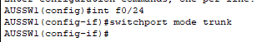

Here, we are configuring FastEthernet port 0/24 **(f0/24)** on **AUSSW1** switch as a trunk port, meaning to allow multiple VLANs to pass through.

Configuring basic security, local user authentication, and SSH on AUSSW1:

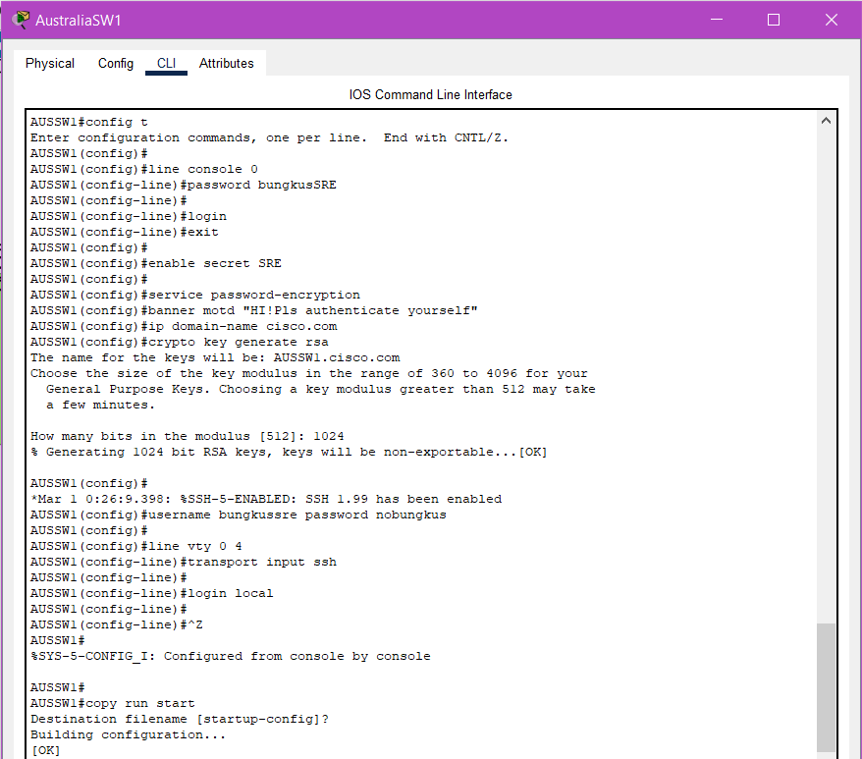

#### 4.1.3.2 Router 1

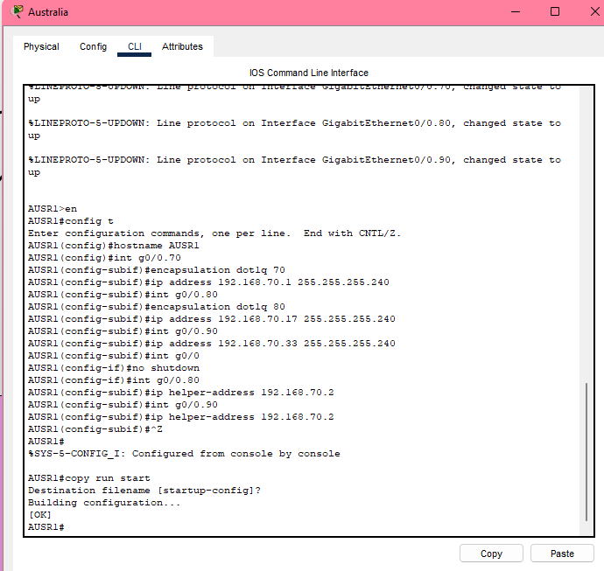



In Australia Router 1, we set the router name to **AUSR1 (hostname AUSR1).** Then, we configure router-on-stick to enable inter-VLAN routing using subinterface on g0/0 between each VLANs:

* *int g0/0.70*

Create and access subinterface g0/0.70, which will be used for inter-VLAN routing for VLAN 70

* *encapsulation dot1Q 70*

This configuration is for subinterface **g0/0.70 (VLAN 70)** uses 802.1Q tagging **(dot1Q)** to handle the VLAN traffic over the trunk link between router and switch.

* *ip address 192.168.70.1 255.255.255.240*

Assign the IP address **192.168.70.1** to the subinterface g0/0.70.

* *int g0/0.80*  
  *encapsulation dot1Q 80*  
  *ip address 192.168.70.17 255.255.255.240*
* Same goes as above for **(g0/0.80)** with IP address **192.168.70.17**.
* *int g0/0.90  
  encapsulation dot1Q 90  
  ip address 192.168.70.33 255.255.255.240*
* Same goes as above, for **(g0/0.90)** with IP address **192.168.70.33.**
* *int g0/0*

*no shutdown*

To active and enable main physical interface **g0/0**, ensure it will not administratively shut down.

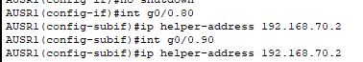



* *ip helper-address 192.168.70.2*

Here, we specify the **DHCP server IP** that will server clients in **VLAN 80 & 90** subinterfaces.

* *copy run start*

Save the current configuration to ensure changes are retained after reboot.

**Summary:**

* g0/0.70 which is subinterface of VLAN 70 (Management) with IP address: 192.168.70.1
* g0/0.80 which is subinterface of VLAN 80 (IT) with IP address: 192.168.70.17
* g0/0.90 which is subinterface of VLAN 90 (Delivery) with IP address: 192.168.70.33

Configuring basic security, local user authentication, and SSH on AUSR1:

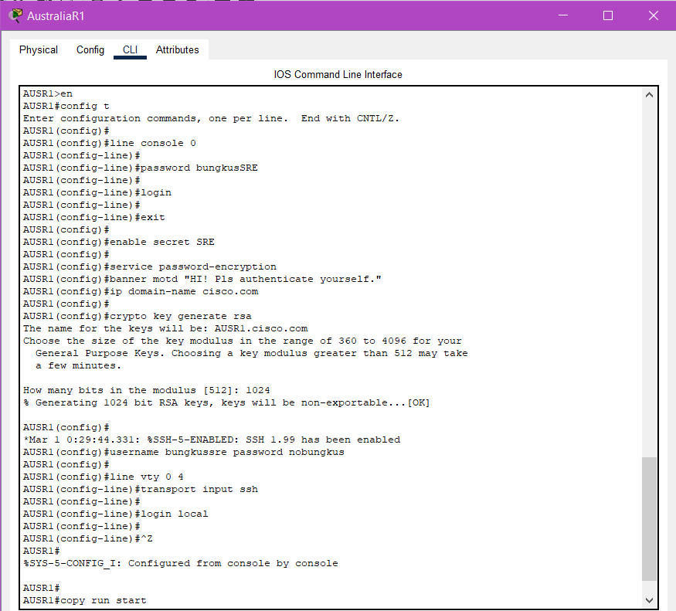

#### 4.1.3.3 Router 2

In Australia Router 2, we set the router name to **AUSR2 (hostname AUSR2).** Then, we configure router-on-stick to enable inter-VLAN routing using subinterface on g0/0 between each VLANs:

**Do the similar configuration as Router 1.**

**VLAN 70:**

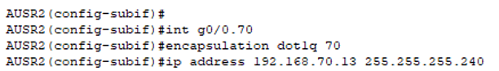

* *int g0.0/70*
* *encapsulation dot1Q 70*
* *ip address 192.168.70.13 255.255.255.240*

**VLAN 80:**

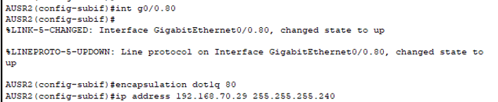

* *int g0.0/80*
* *encapsulation dot1Q 80*
* *ip address 192.168.70.29 255.255.255.240*

**VLAN 90:**

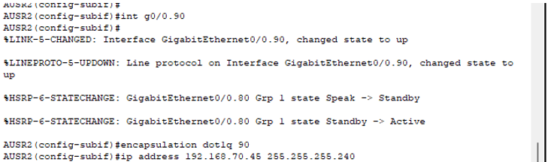

* *int g0.0/90*
* *encapsulation dot1Q 90*
* *ip address 192.168.70.45 255.255.255.240*

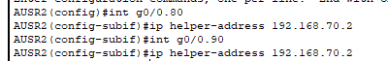

* *ip helper-address 192.168.70.2*
* *copy run start*

Configuring basic security, local user authentication, and SSH on AUSR2:

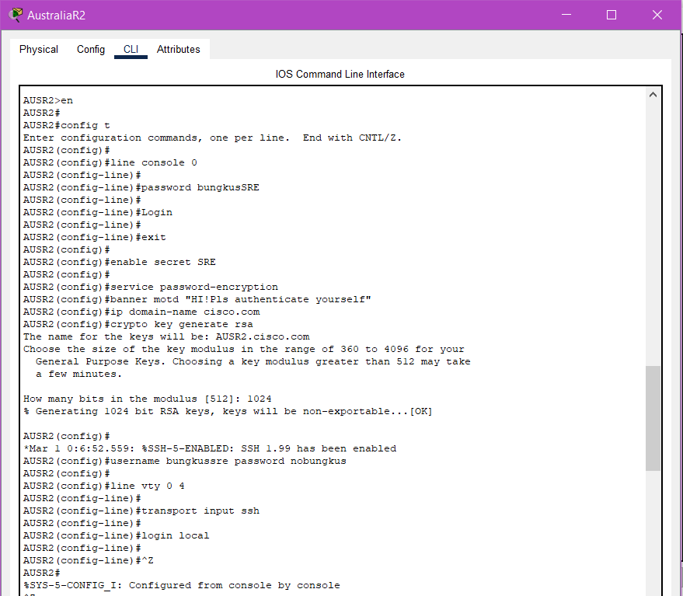

## 4.2 WAN

A configuration of default static route is made for the router and multilayer switch to define specific paths for network traffic to reach remote branch.

Assign ip for serial port se0/0/0 in KLR1 which connected with AUSR1

* *int se0/0/0*
* *ip address 10.0.0.1 255.255.255.240*

Configuration of static routes to tell KLR1 how to reach subnets located behind AUSR1

* *ip route 192.168.70.0 255.255.255.240 10.0.0.2*
* *ip route 192.168.70.16 255.255.255.240 10.0.0.2*
* *ip route 192.168.70.32 255.255.255.240 10.0.0.2*

We tell KLR1 the subnet behind AUSR1 and the next-hop IP address

Last, verify the configuration.

* sho ip route static

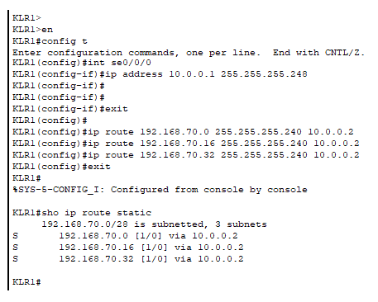

Same as KLR1, serial port ip in AUSR1 is set. Then config the static routes in AUSR1 to KLR1.

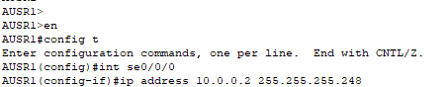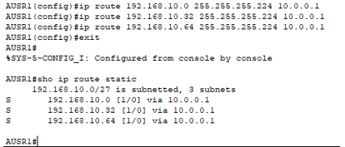

Serial port ip in KLR2 is set. Then config the static routes in KLR2 to AUSR2.

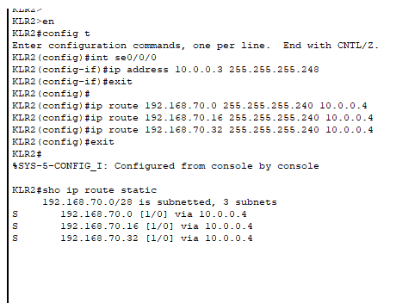

Serial port ip in AUSR2 is set. Then config the static routes in AUSR2 to KLR2.

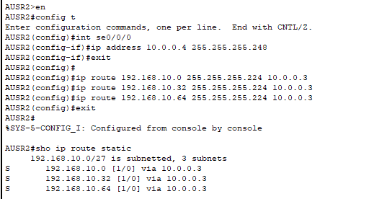

Serial port ip in AUSR1 is set. Then config the static routes in AUSR1 to SGR1.

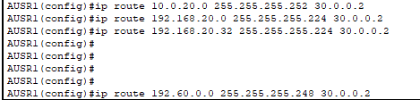

Serial port ip in SGR1 is set. Then config the static routes in SGR1to AUSR1.

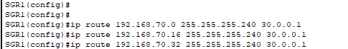

Serial port ip in SGR1is set. Then config the static routes in SGR1to KLR1.

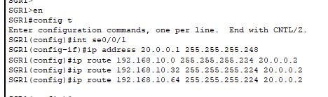

Serial port ip in KLR1 is set. Then config the static routes in KLR1 to SGR1.

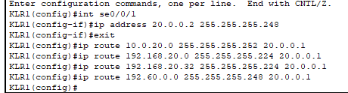

Next, configuration for multilayer switch.

Create static route for SGSW1(Multilayer switch) to access network in branch KL.

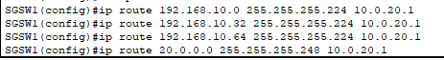

Create static route for SGSW1(Multilayer switch) to access network in branch AUS.



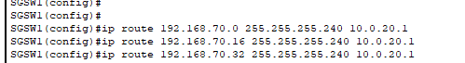

# 5.0 WLAN Architecture (AUS) – Yaw Kai Yuan TP080121

Now in Australia, click on the Server-PT and renamed it as DHCP. Next, go to “Desktop” Tab and give the IP address to the server. Here, assign 192.168.70.2 to DHCP server. Same goes to Subnet Mask and Default Gateway.

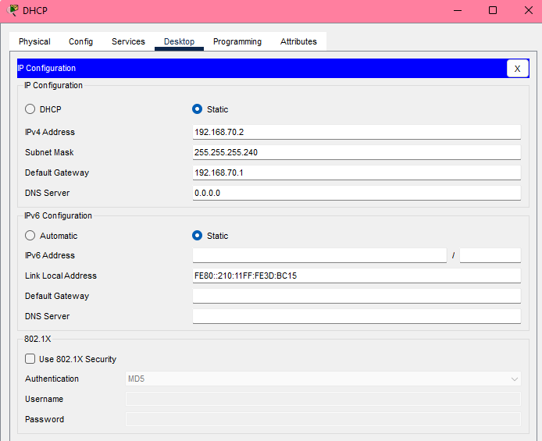

Come to WLC (Wireless LAN Controller) and click on “Config” tab. Then, click the Management and change the IP address to our IP address. Same goes to Subnet Mask and Default Getaway.

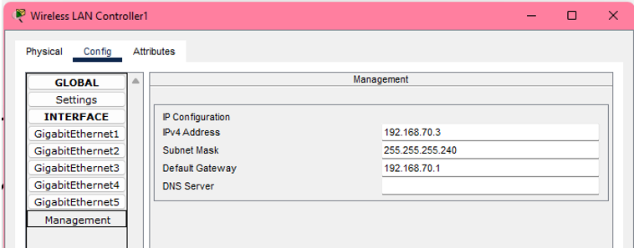

Go to the PC, assign 192.168.70.4 as IP address. Same goes to Subnet Mask and Default Getaway.

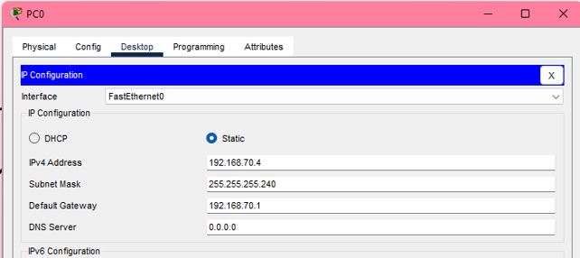

Click DHCP server and go to the “Services” tab select the DHCP service. Make the interface service “ON” and named the Pool name as “ManagementPool”. Assign the default getaways 192.168.70.1 and 192.168.70.5 as Start IP Address. Then, enter our Subnet Mask and WLC address.

Next, same goes to our “DeliveryPool” and “ITPool”.

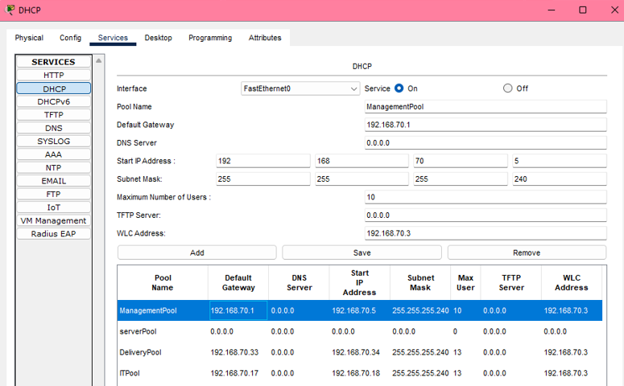

Click to each Light Weight Access point and go to “Config” tab. Click the “Static” button and click back “DHCP” button.

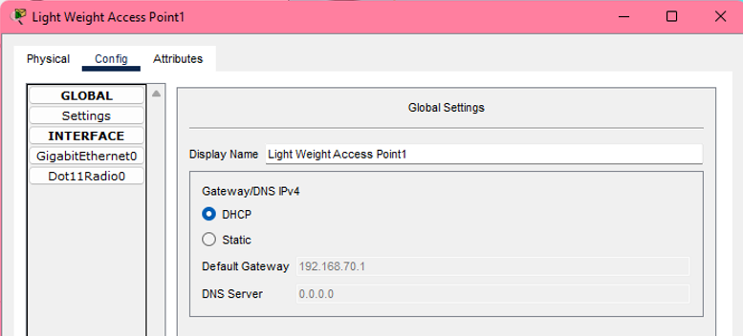

Go to PC, click “Desktop” tab and Web browser. In the URL, specify the WLC IP address. [*http://192.168.70.3*](http://192.168.70.3) and click GO. It will prompt out the website for creating the account.

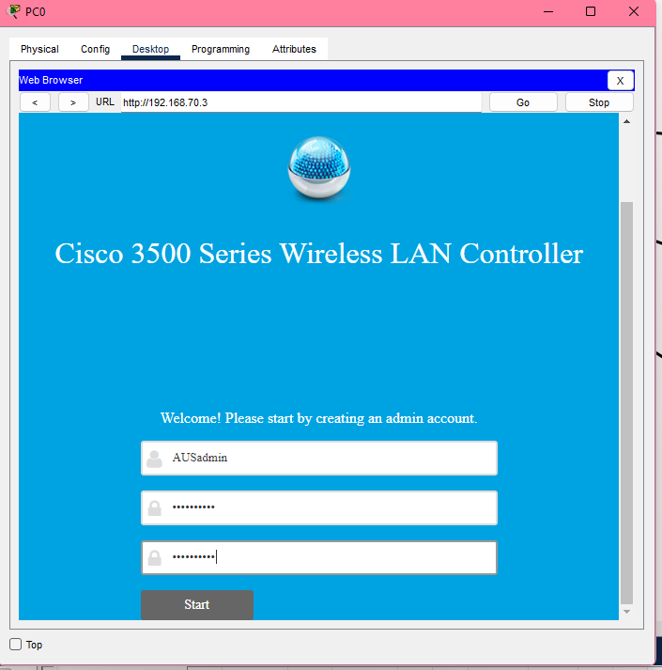

Username: AUSadmin

Password: Admin12345

Set up the Controller. Give the System Name as CloudCoAustralia. Then, assign the Management IP address 192.168.70.3, Subnet Mask 255.255.255.240, Getaway IP 192.168.70.1. And give the Management VLAN ID: 70. Then, click Next.

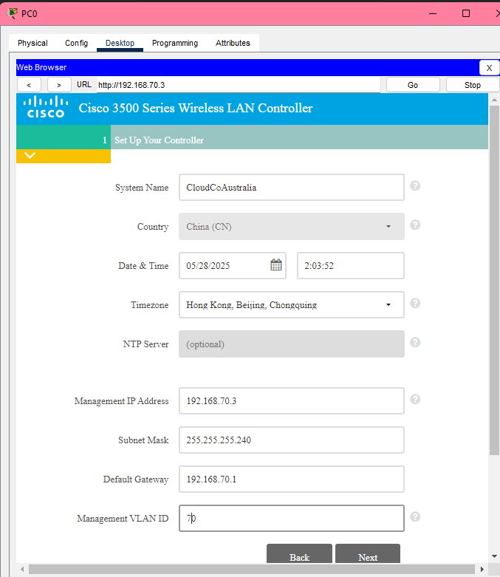

Create the Wireless Network. The Network Name set as AUSManagement. Choose WPA2 Personal as Security. Next, give the Password:12345678 and click Next.

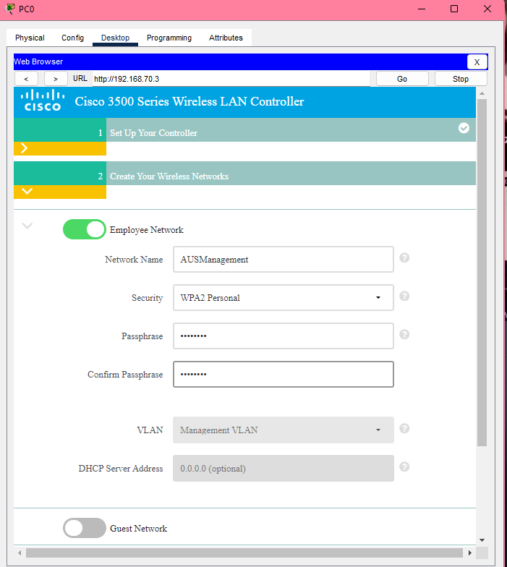

After showing this page, click “Apply” below.

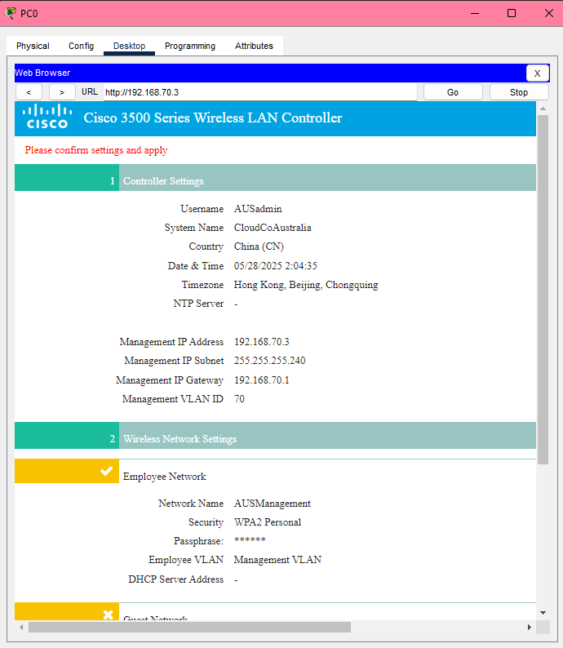

It will be saving the configuration. This will take a long time, so click Stop button at the top right corner and close it.

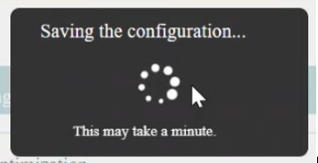

Go back to the Web browser. Now, give the URL as [*https://192.168.70.3*](https://192.168.70.3), it will prompt out the webpage. Key in the username as password that created just now. Press Login.

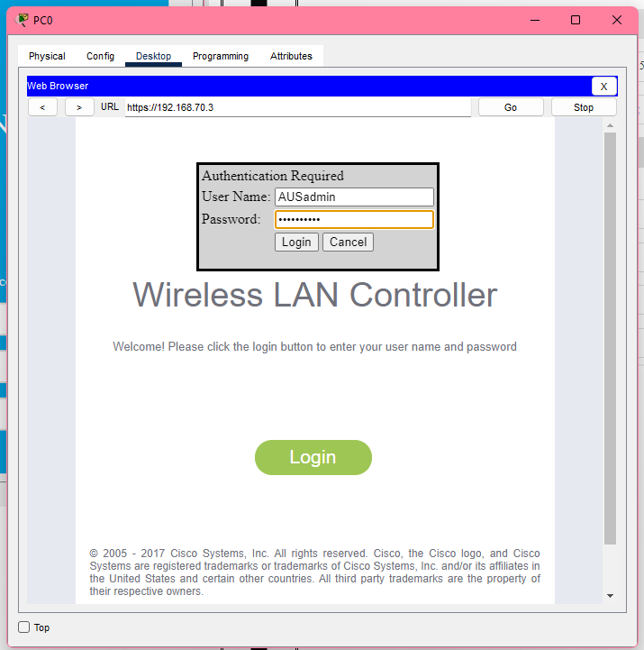

After login, go to “Controller” tab and click Interfaces controller on the left side. Then, click “new” on the top right corner.

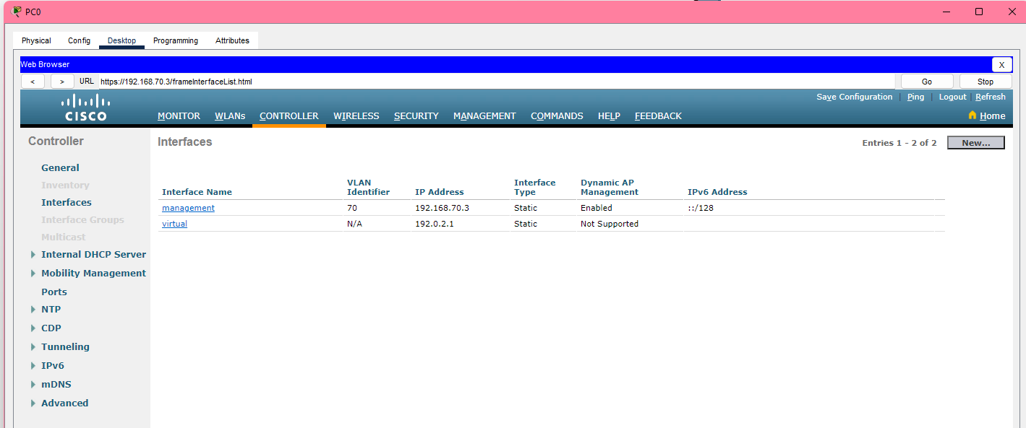

Enter the Interface name and VLAN ID. Which is VLAN 70 and 80.

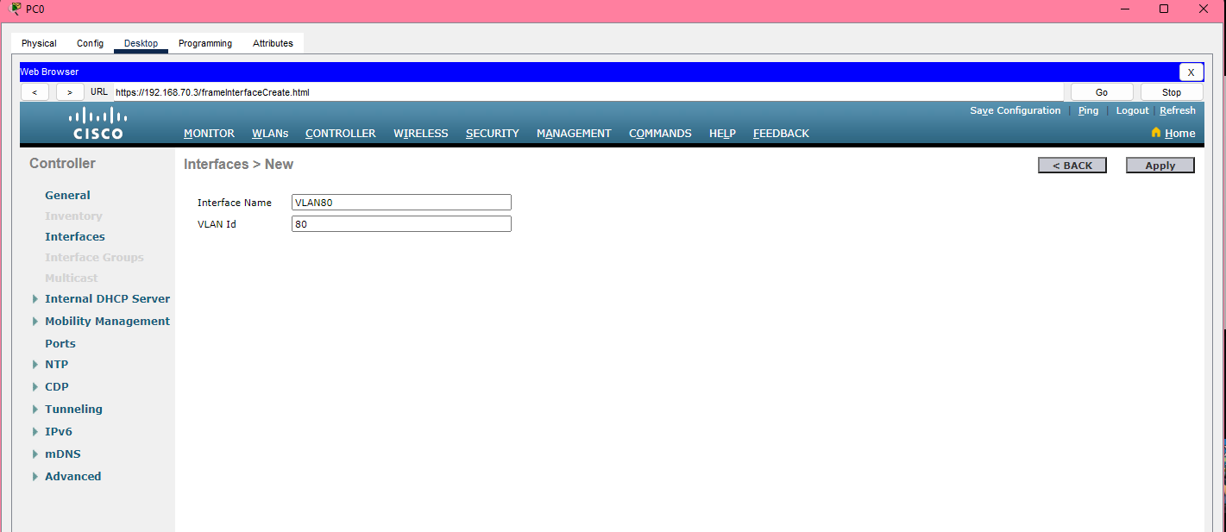

Under the physical information, we enter the VLAN Identifier, IP address, Netmask, Gateway, DHCP server for our VLAN 80. Click “Apply” after done entered.

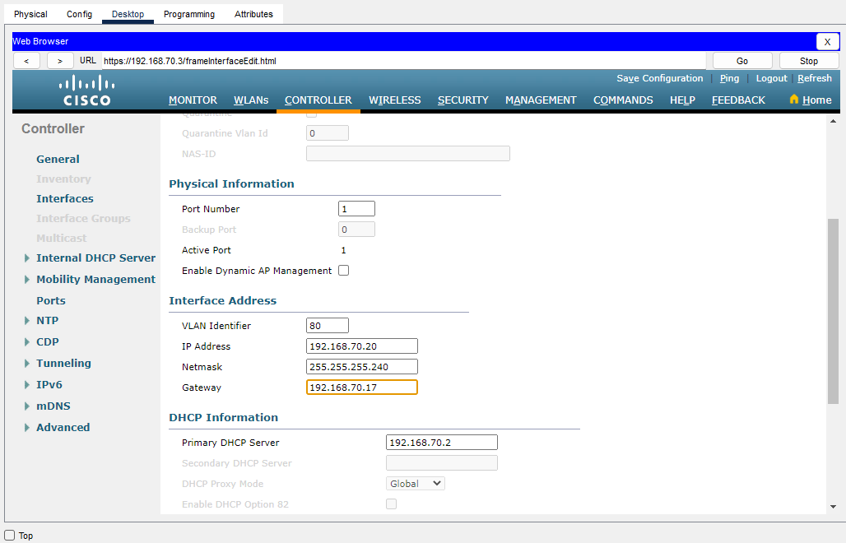

Same goes as above, do the same step for VLAN 90.

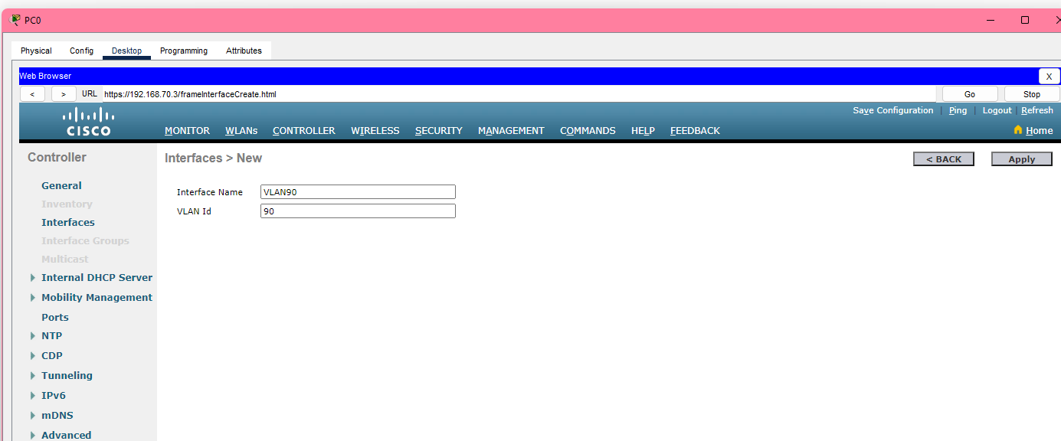

Enter the IP address and others for VLAN 90. After done, click “Apply” button.

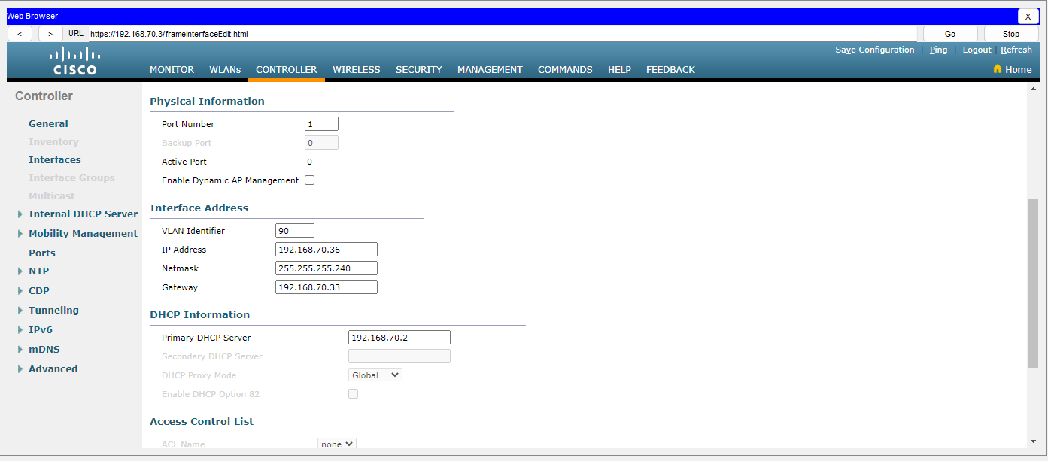

Go to WLANs link now at the right side. Then, press “1” to edit.

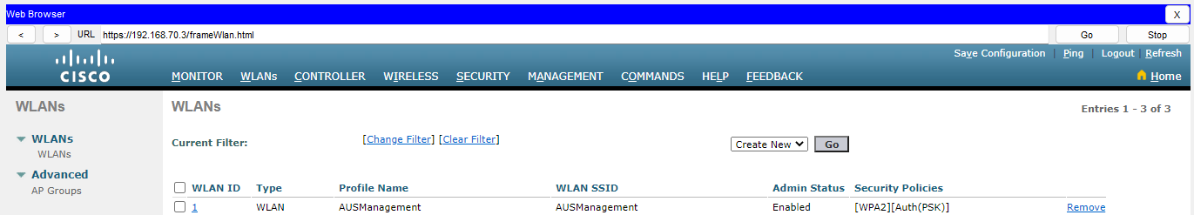

Go to the “Advanced” tab, and make sure below check box is enabled. Click “Apply” button then.

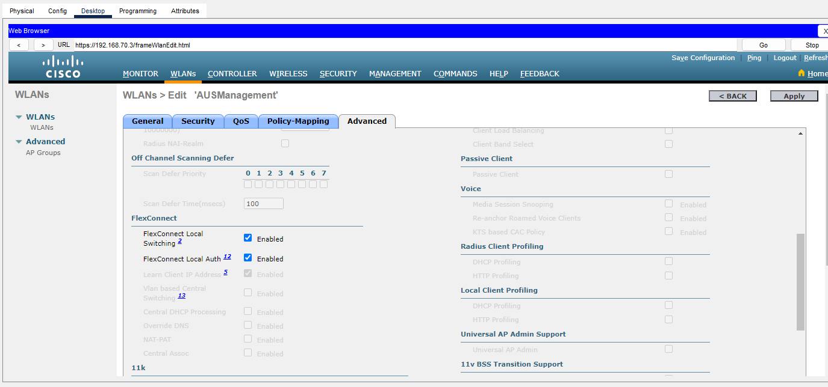

Then, go back to the WLANs tab, and press “Go” button to create a new WLAN.

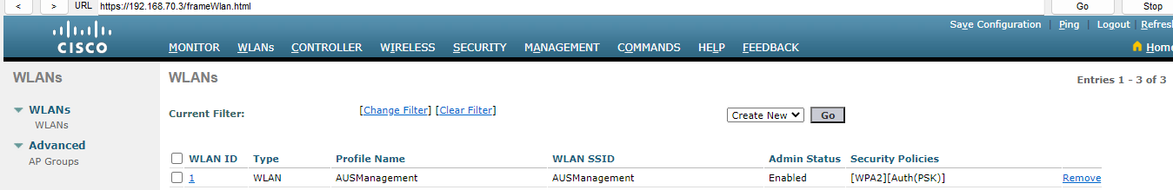

Enter the profile name “AUSIT” and SSID. Click “Apply” button after done.

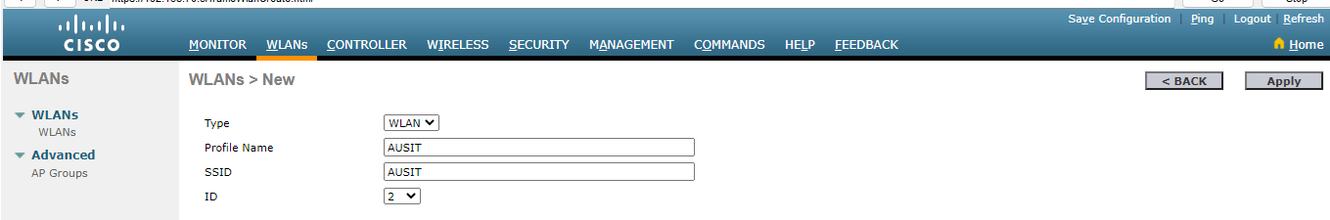

It will prompt out the page below, tick enabled and select VLAN 80.

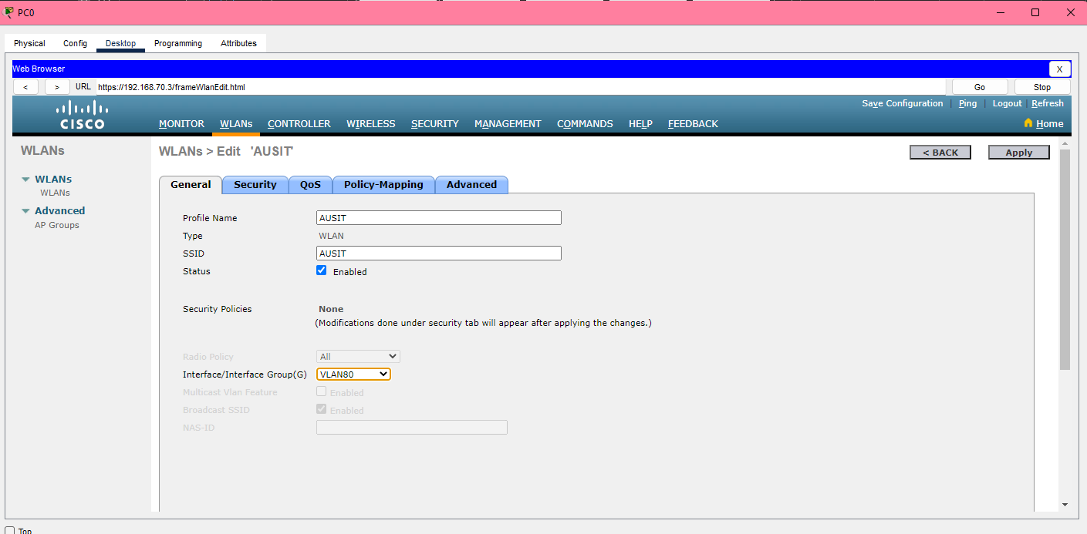

Next, click the “Security” tab go to Layer 2. Here, select WPA+WPA2. Tick the “WPA2 Policy” and “PSK” enable.

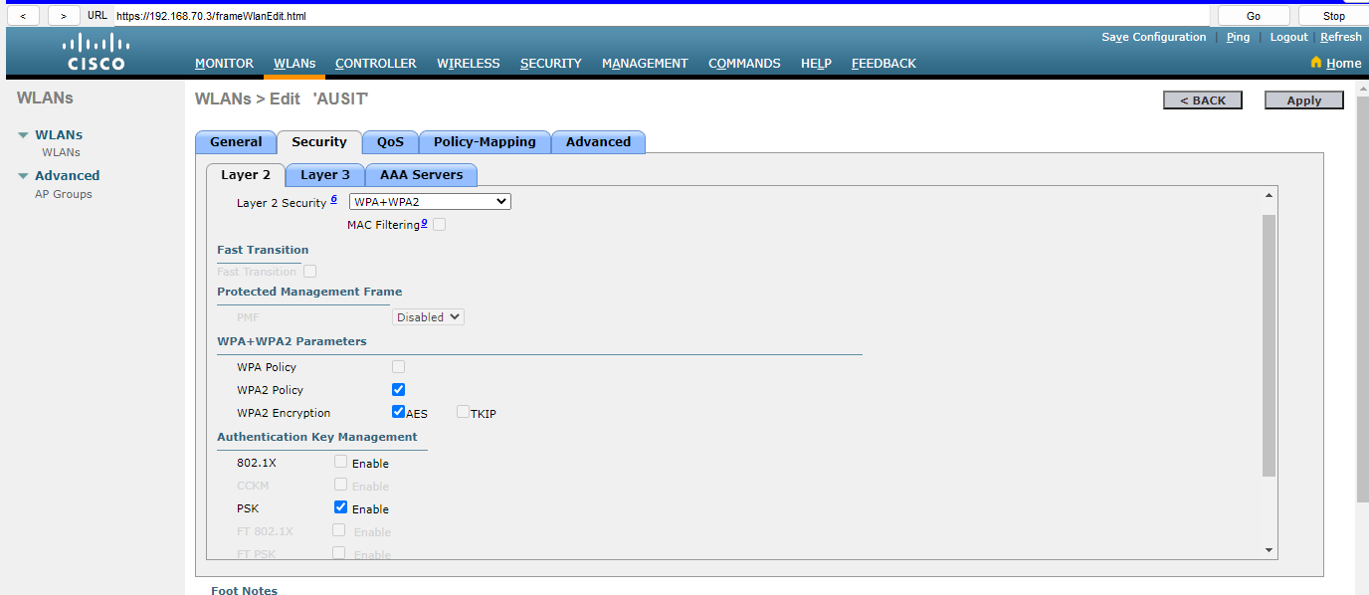

And set “PSK” format as 87654321. Note that don’t use same password with others. Click “Apply” if done.

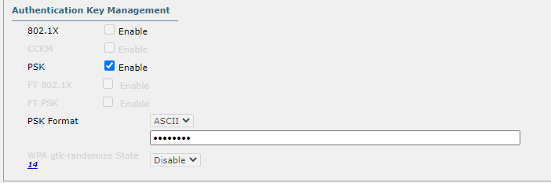

Then, go “Advanced” Tab and tick these two check boxes. Press “Apply” after done.

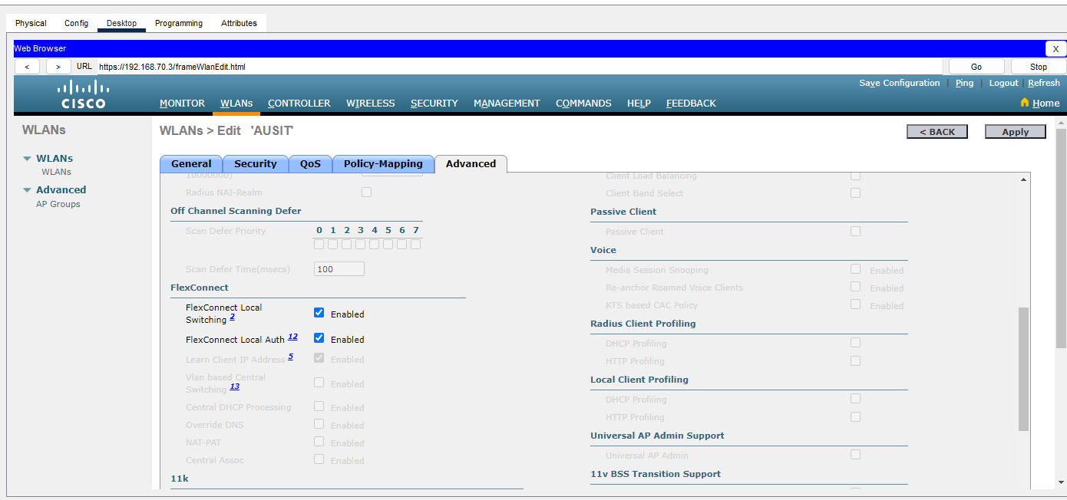

Now, go back to WLANs, create a new WLAN “AUSDelivery” and click “Apply”.

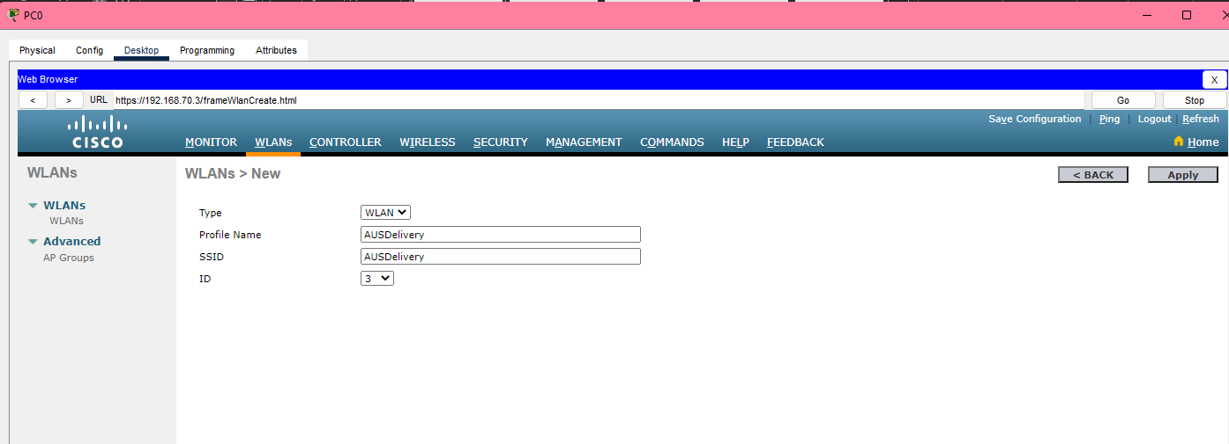

Do the same thing, click Enabled and select VLAN 90.

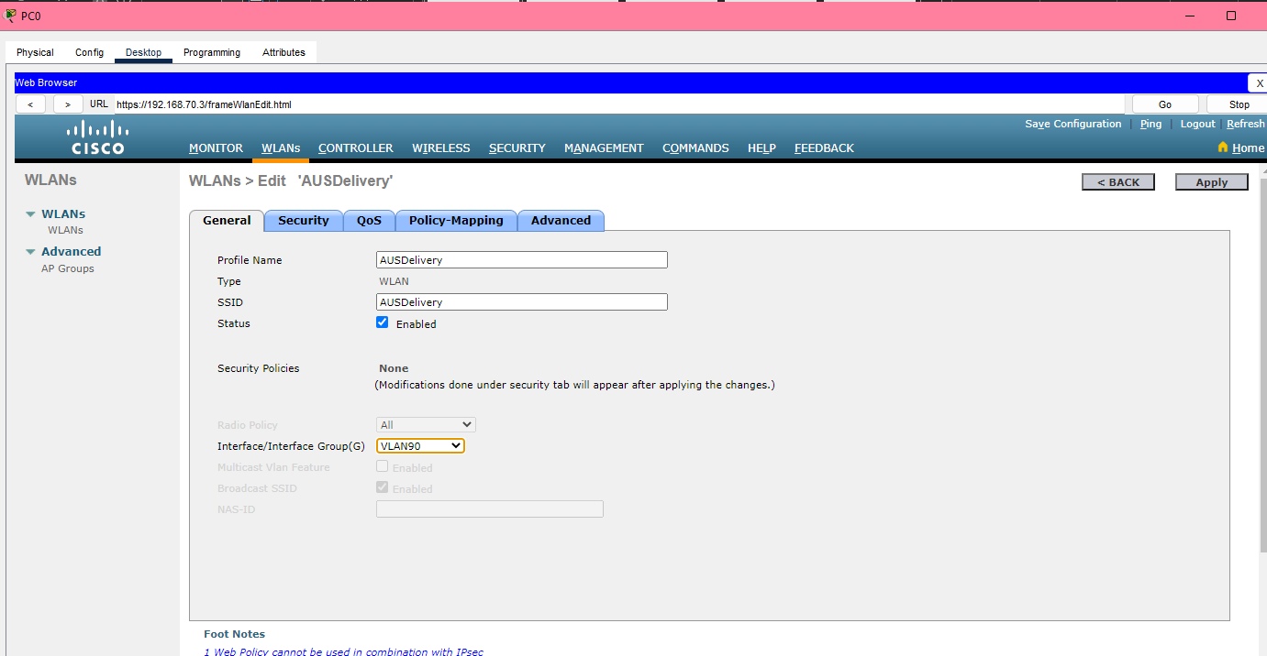

Select WPA+WPA2, tick WPA2 policy and “PSK” is enable.

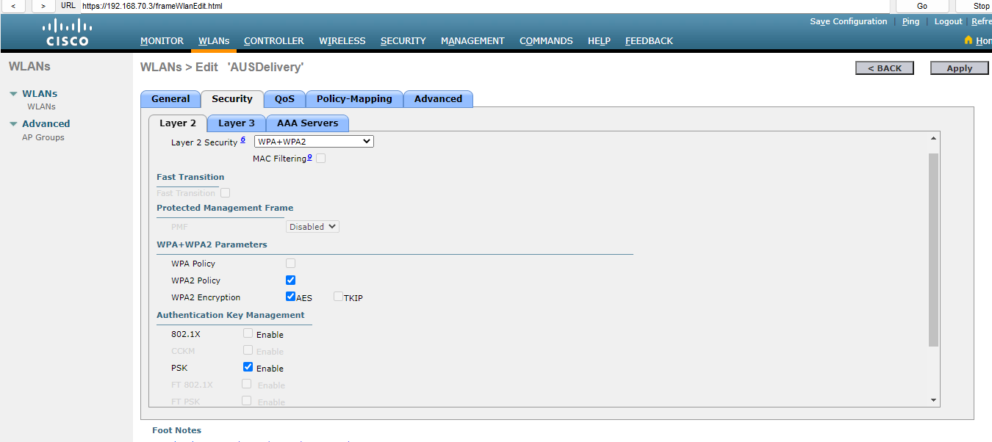

Set “PSK” format as 56781234.



Go “Advanced” Tab and tick these two check boxes. Press “Apply” after done.

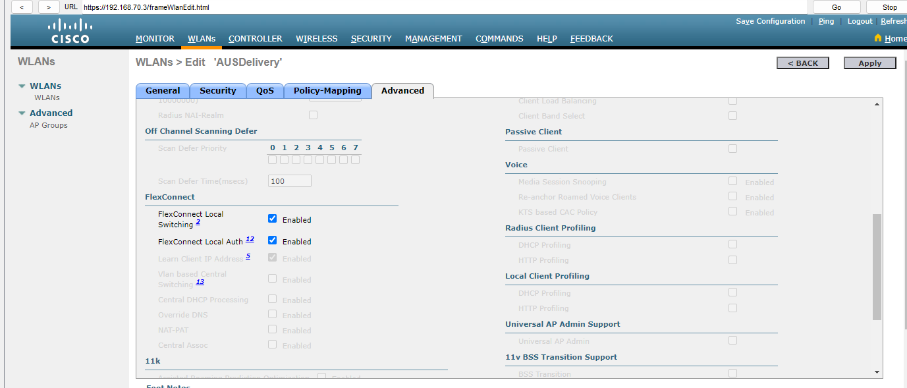

Click “OK” for this dialog box.

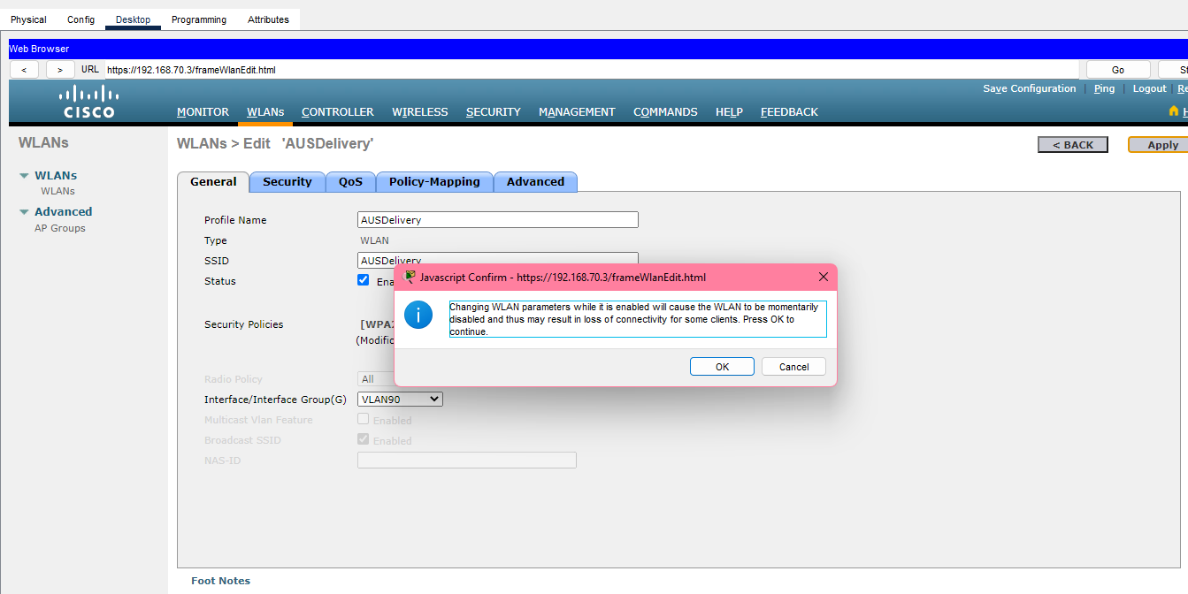

There will have 3 WLAN created in our WLANs now.

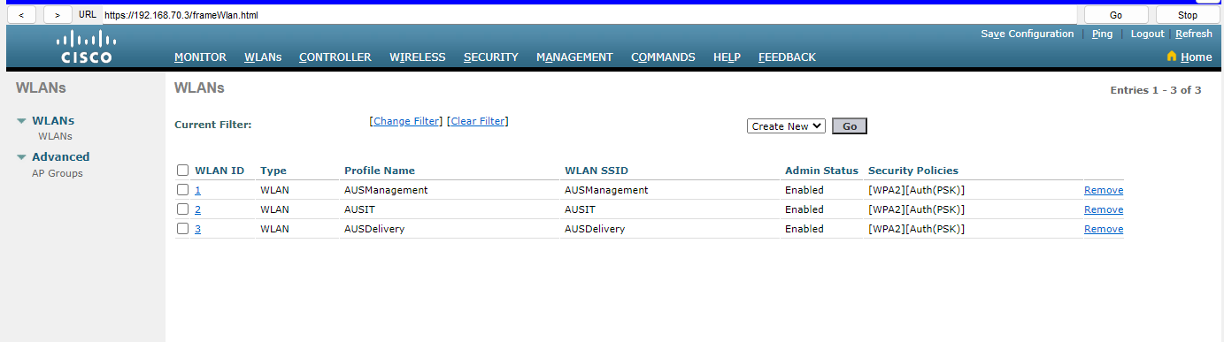

Then, go to “Controller” tab and click “management”.

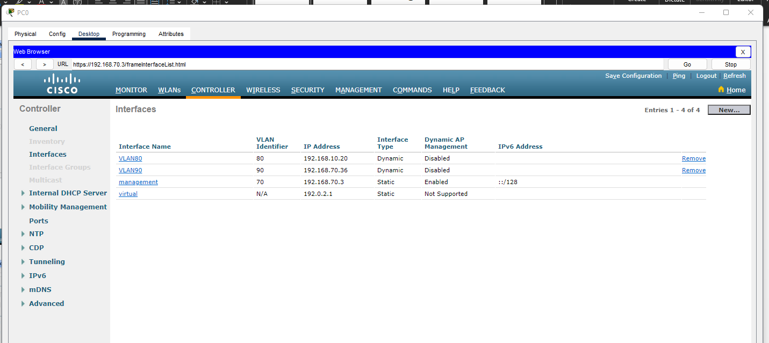

Enter the Primary DHCP Server address which is same as DHCP Server 192.168.70.2.

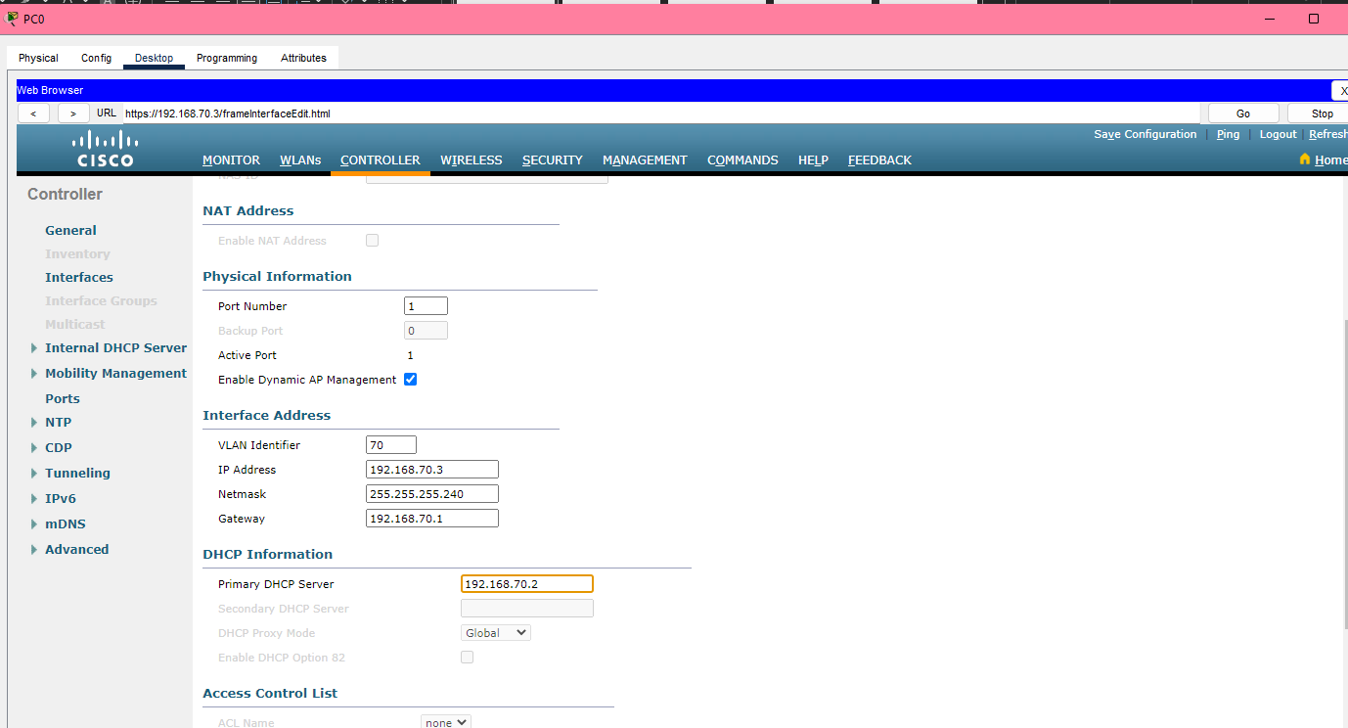

Then save the new configuration. Press “OK” for this dialog box.

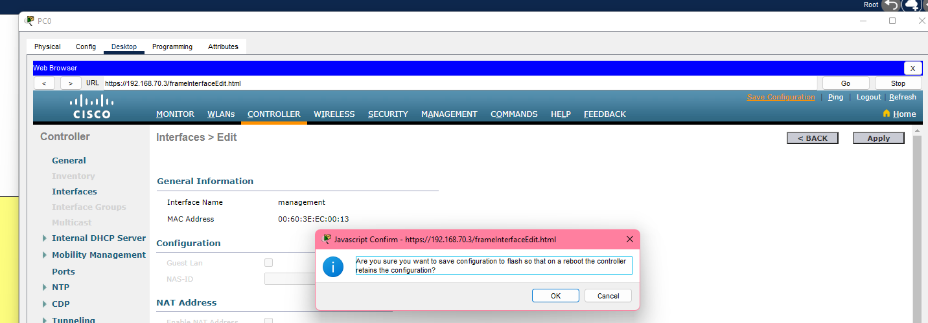

Go to “AP Groups” at the left side, then click “Add Group” at the top right corner.

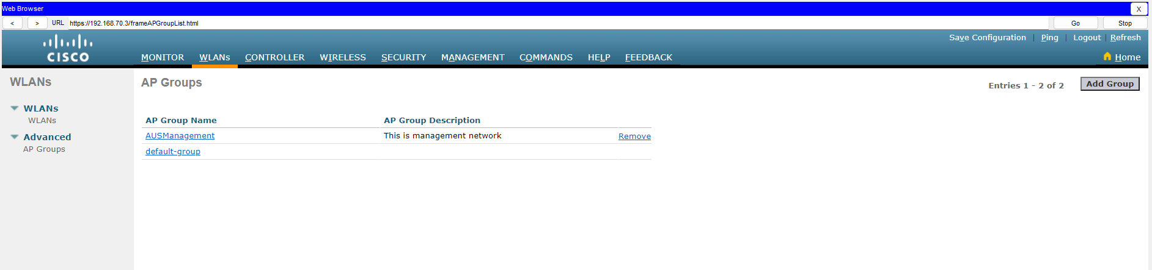

Give the AP Group Name “AUSManagement” and Description. Click Add after done.

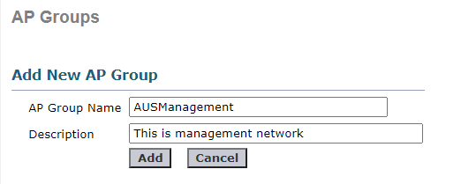

Then do the same step, add another group.



AP Group Name as “AUSIT” and enter description. Click Add after done.

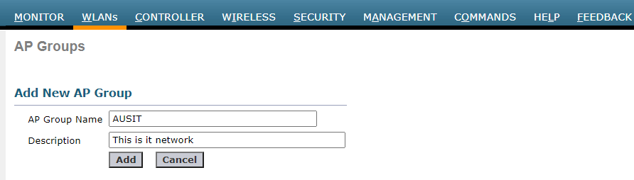

Add another group “AUSDelivery” and description. Click Add after done.

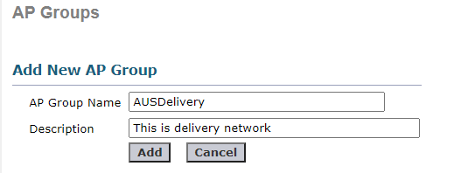

Now, each network needs to connect to the access point. First is “AUSManagement”. Click it.

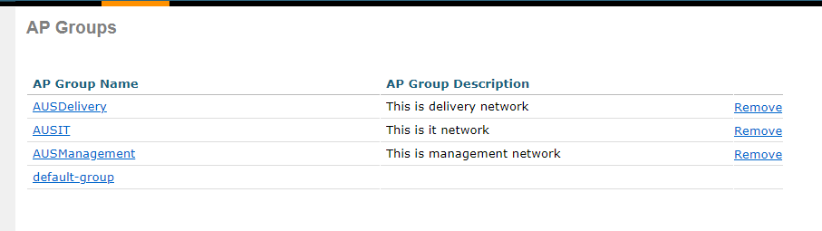

Go to WLANs tab and click “Add New”. Select the correct SSID and Click Add button below.

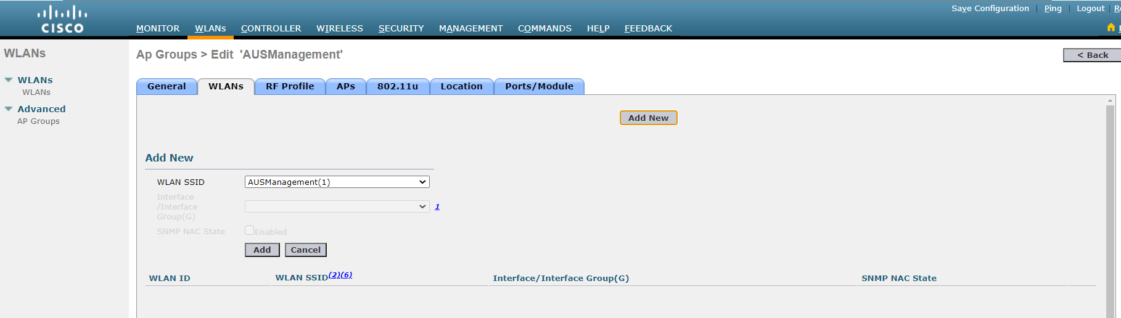

Then, go Aps tab, and select corresponding AP of “AUSManagement” and add APs. (Access Point 1)

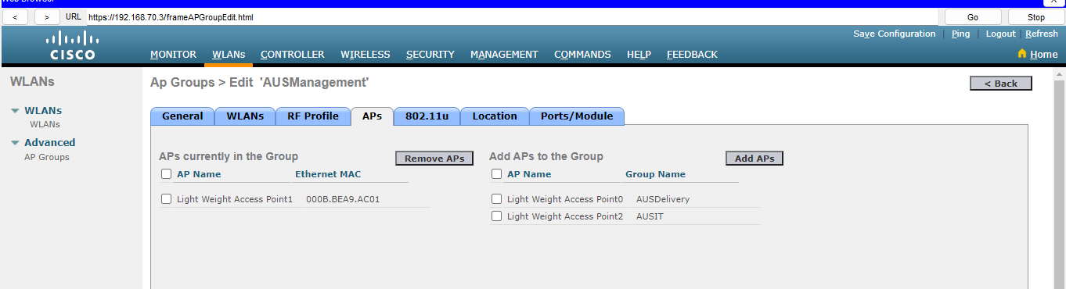

Same goes to “AUSIT”.

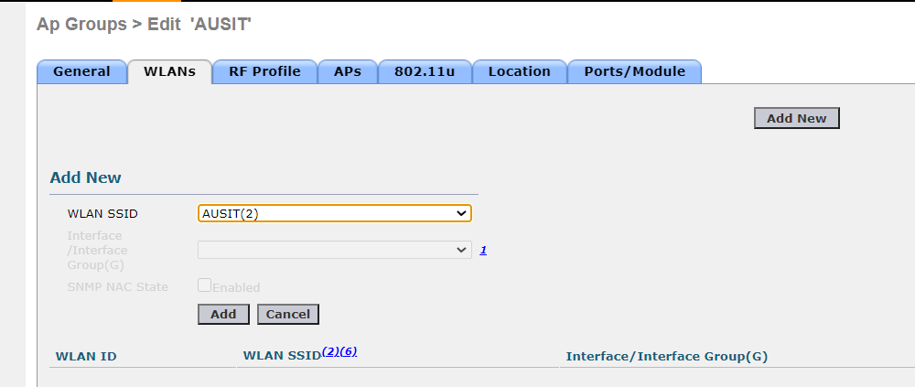

Select the corresponding AP of “AUSIT” and click “OK” for the dialog box.

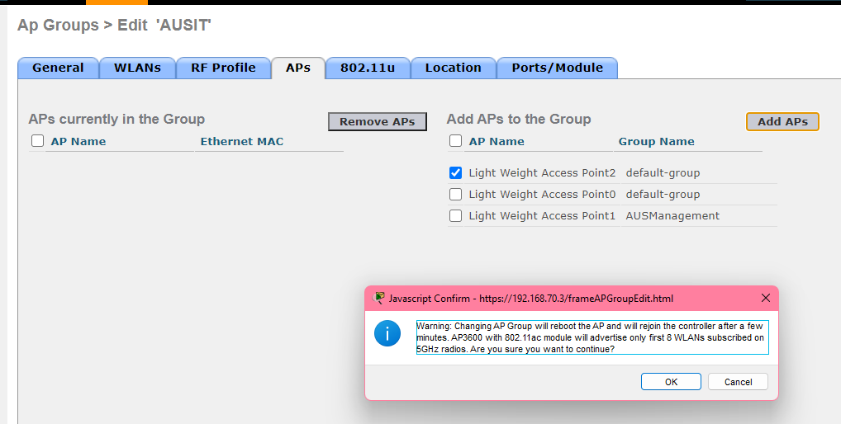

Same goes to “AUSDelivery”.

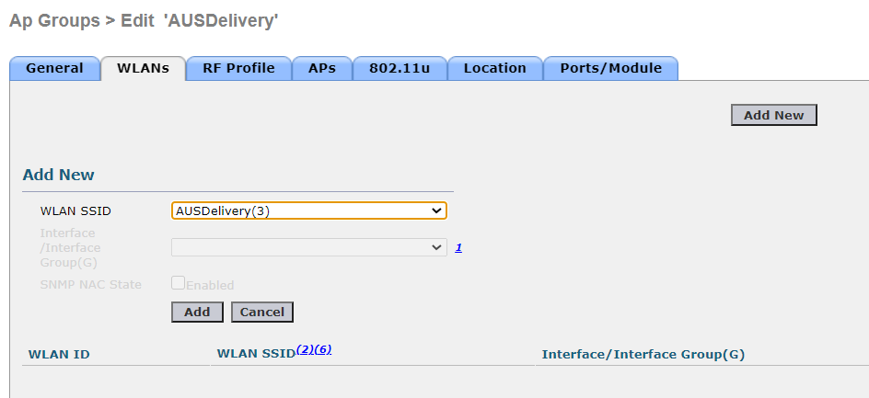

Select the corresponding AP of “AUSDelivery” and click “OK” for the dialog box. After done, click Logout button.

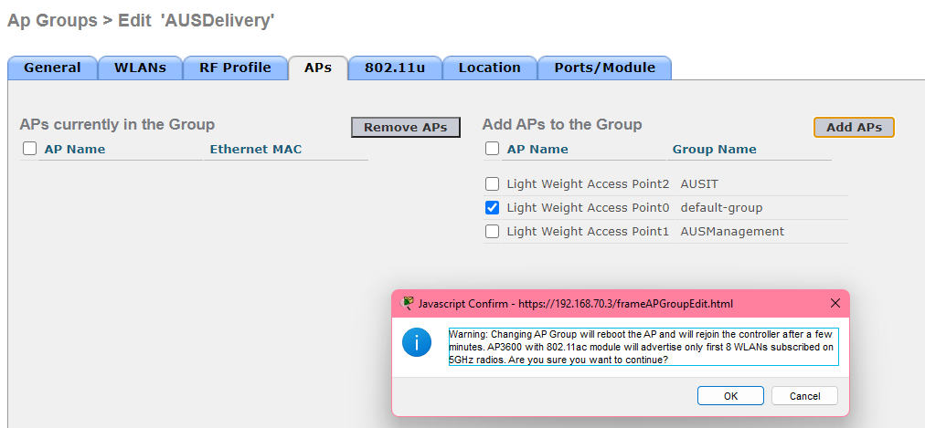

Now, all the devices of each department need connect to Access Point, so change the SSID of the devices.

**AUS management device:**

Change the SSID to “AUSManagement”. Click the WPA2-PSK and enter the PSK Pass Phrase “12345678”. Then, click the Static button and click back the DHCP button back.

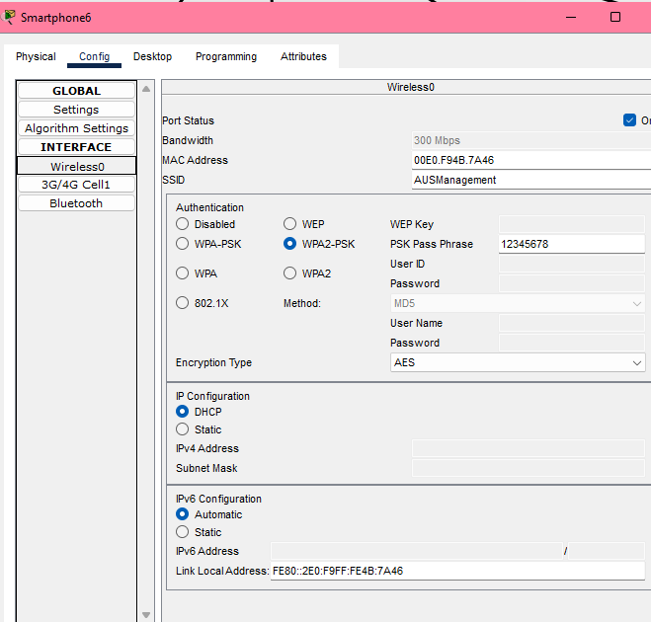

**AUS IT device:**

Same goes as AUS management. Change the SSID and enter the PSK Pass Phrase.

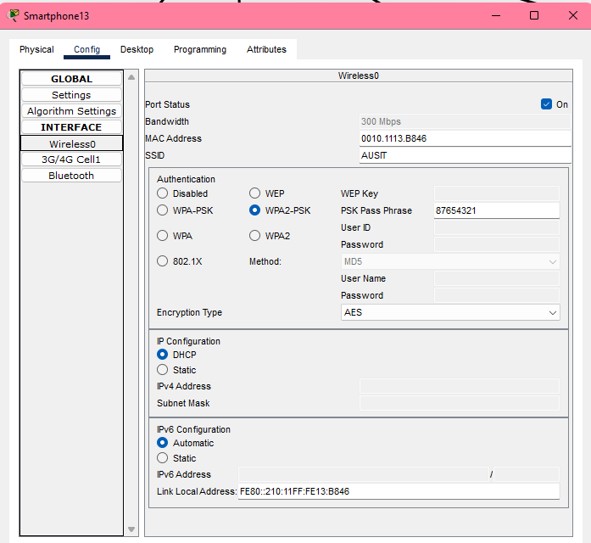

**AUS Delivery device:**

Same goes as above. Change the SSID and enter the PSK Pass Phrase.

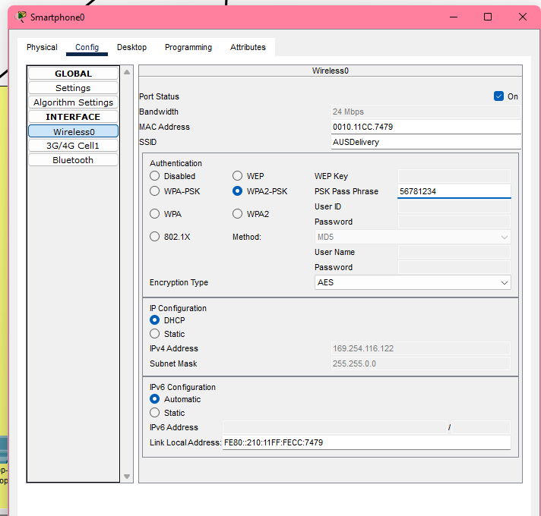

# 6.0 EtherChannel Implementation (KL) – Voon Wei Siang TP080429

**KLSW1:**

Configuring EtherChannel group 1 for fa0/21-22 in switch 1:

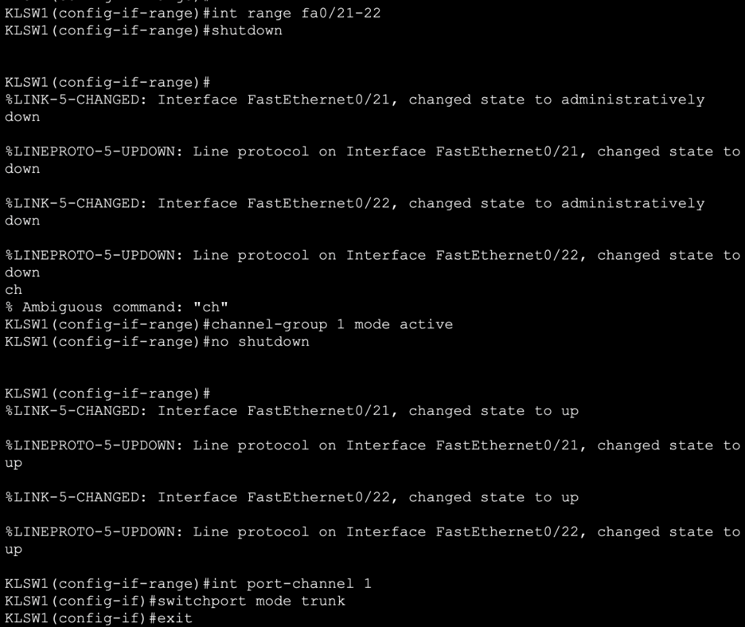

Explanation for example switch 1 fa0/21-22:

* *int range fa0/21-22*

Select and access to the range of FastEthernet interfaces from fa0/21 to fa0/22. (need to be modify based on different group)

* *shutdown*

Temporarily disables the selected interfaces to safely apply configuration changes.

* *channel-group 1 mode active*

Create EtherChannel group 1 using LACP with mode active and add selected interfaces into this channel. (need to be modify based on different group)

* *no shutdown*

To re-enables the interfaces.

* *int port-channel 1*

Access to logical interface Port-Channel 1. (need to be modify based on different group)

* *switchport mode trunk*

Set Port-Channel 1 to trunk mode to carry traffic for multiple VLANs.

* *exit*

To exit the interface Port-Channel 1.

Same as above, configuring EtherChannel group 3 for fa0/19-20 in switch 1:

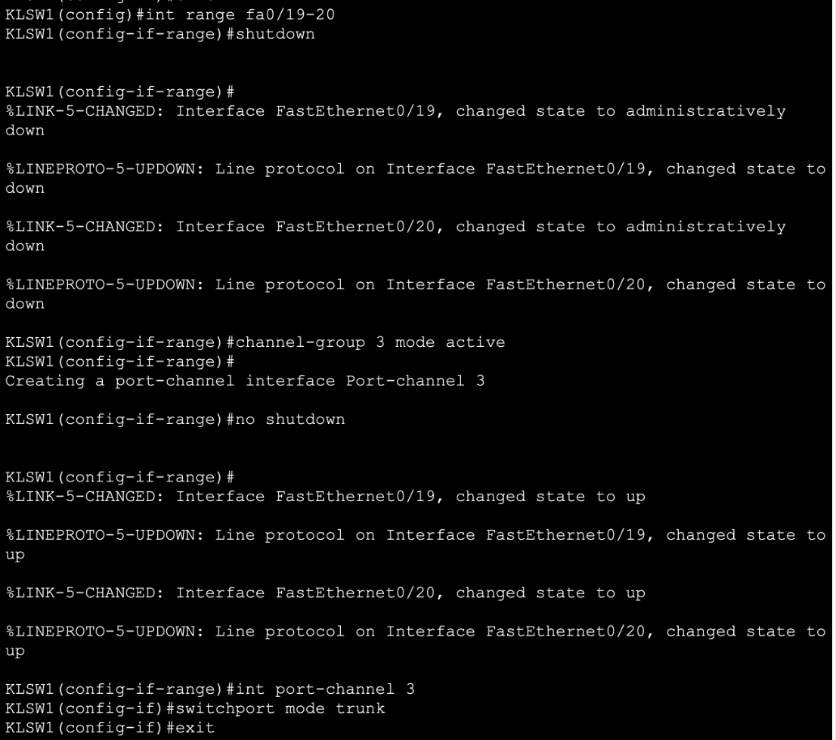

**Switch 2:**

Same as above, configuring EtherChannel group 1 for fa0/21-22 in switch 2:

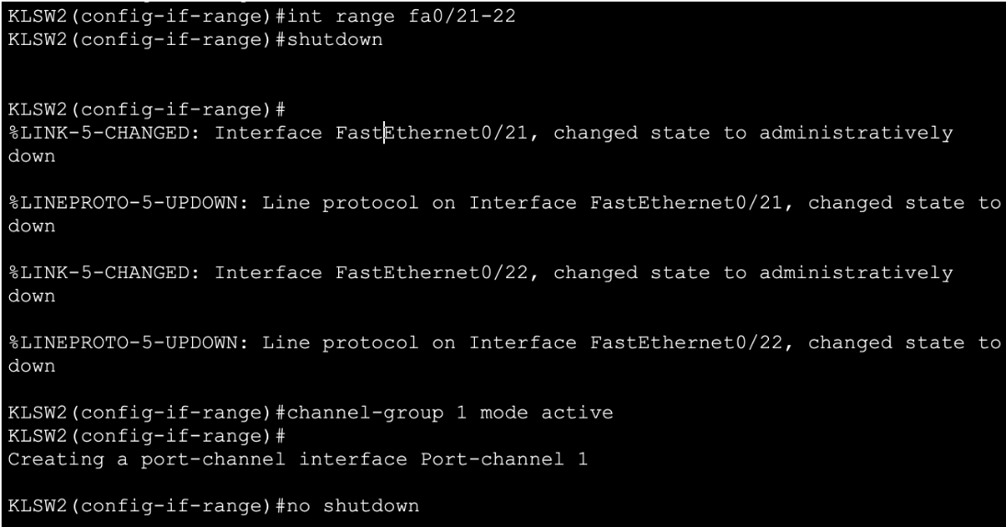

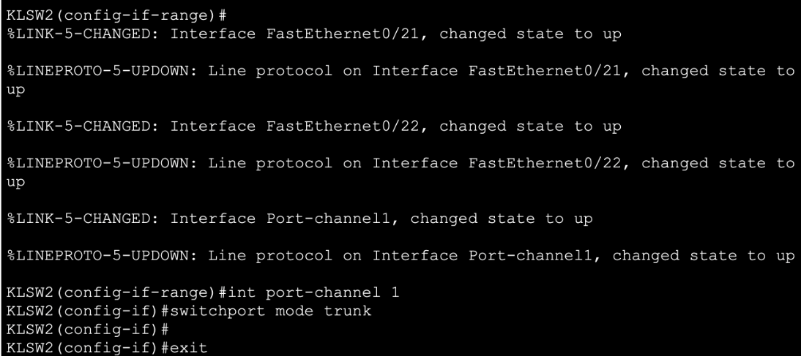

Same as above, configuring EtherChannel group 2 for fa0/23-24 in switch 2:

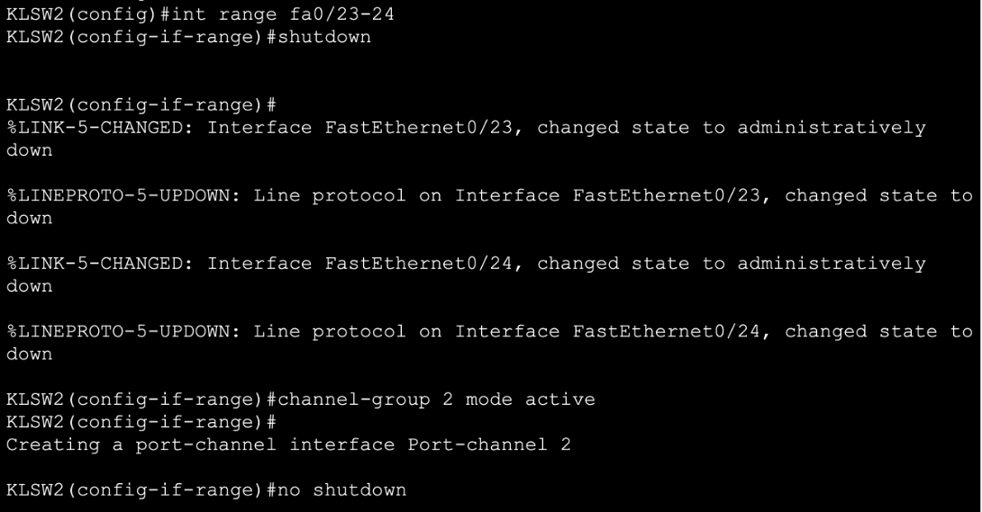

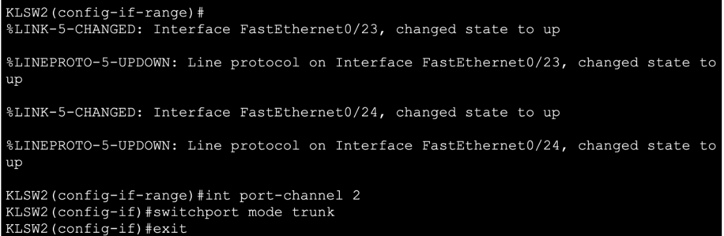

**Switch 3:**

Same as above, configuring EtherChannel group 2 for fa0/23-24 in switch 3:

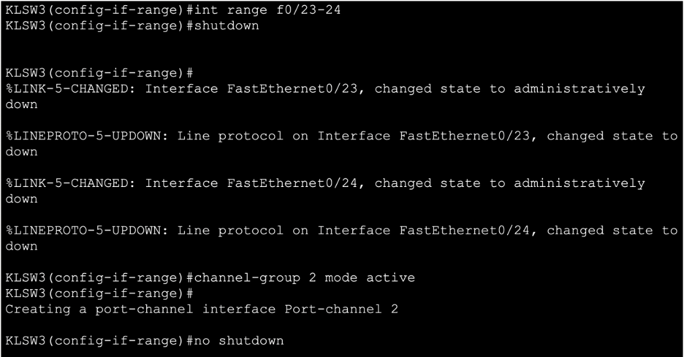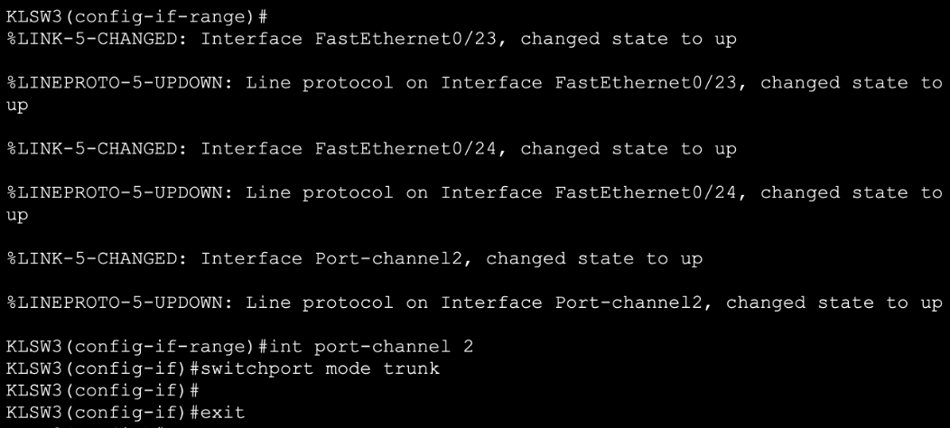

Same as above, configuring EtherChannel group 3 for fa0/19-20 in switch 3:

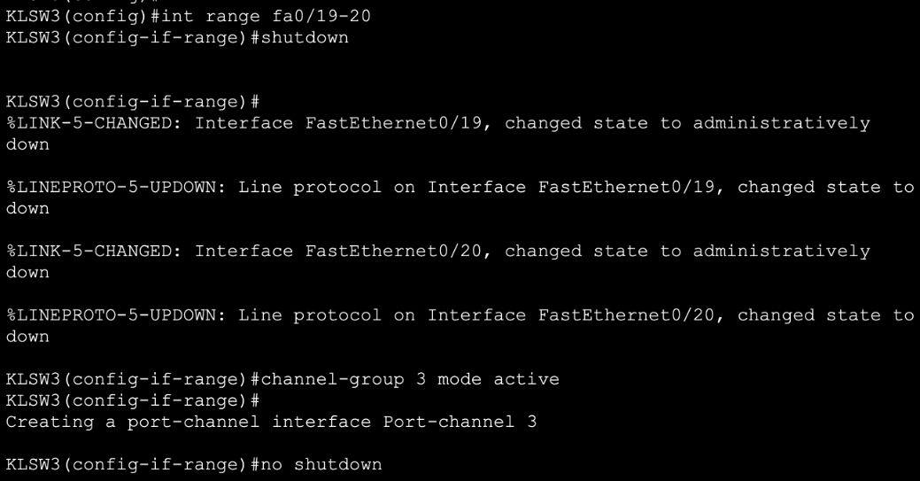

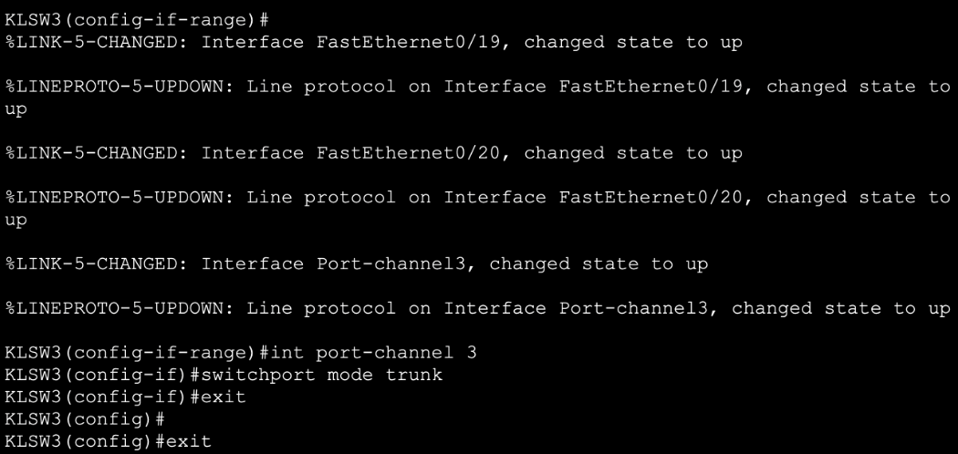

**Summary:**

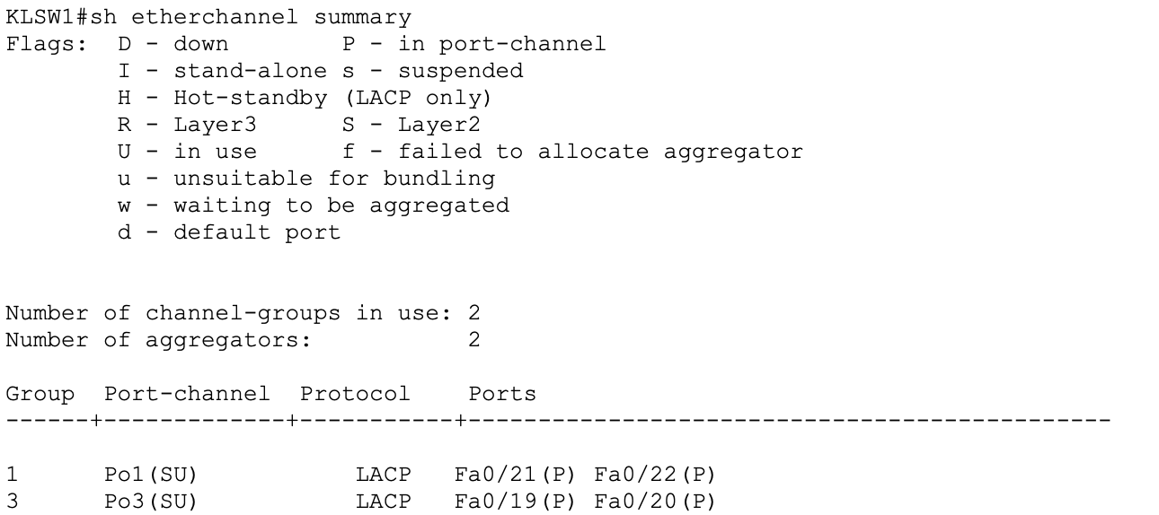

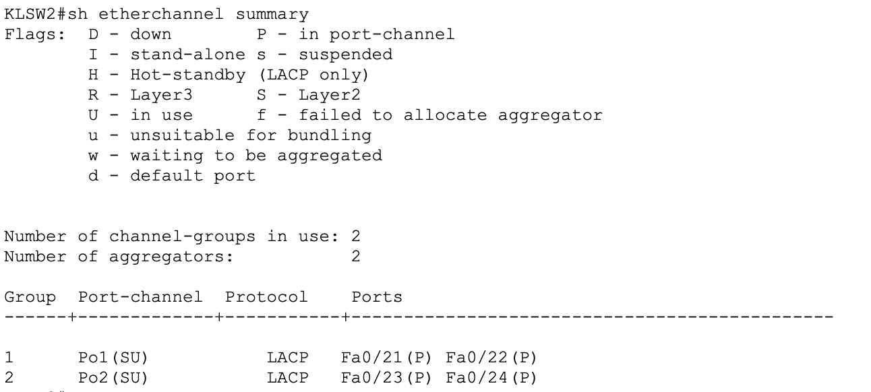

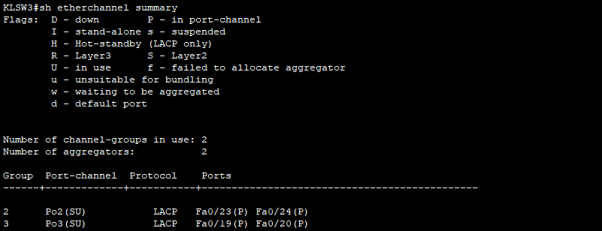

On **KLSW1, KLSW2 and KLSW3**, by configuring 3 etherchannel for connecting switch to switch using LACP active mode.

* Group channel 1: fa0/21-22 on KLSW1 and KLSW2
* Group channel 2: fa0/23-24 on KLSW2 and KLSW3
* Group channel 3: fa0/19-20 on KLSW1 and KLSW3

# 7.0 HSRP Implementation – Ho Kun Yun TP080482

## 7.1 KL

### 7.1.1 Router 1

Configuring HSRP on router 1 subinterface g0/0.10 for KL branch:





* *int g0/0.10*

Create and access subinterface g0/0.10, which will be used for inter-VLAN routing for VLAN 10.

* *standby version 2*

Enables HSRP version 2, which supports more groups and IPv6 compared to version 1.

* *standby 1 ip 192.168.10.1*

Assigned 192.168.10.1 as virtual IP address for HSRP group 1, it shares with router 2.

* *standby 1 priority 120*

The router 1’s HSRP priority is set to 120, giving the higher preference over router 2.

* *standby 1 preempt*

Enables router 1 to **take over** the active role.

Same as above, configuring HSRP on router 1 subinterface g0/0.20 for KL branch:





Same as above, configuring HSRP on router 1 subinterface g0/0.30 for KL branch:





**Summary:**

On **KLR1**, configure **HSRP version 2** across **VLANs 10, 20, 30** using subinterface **g0/0.10, g0/0.20, g0/0.30**. Besides, KLR1 is given the priority of 120 and enabled preemption on all interfaces.

* VLAN 70 🡪 Virtual IP: 192.168.10.1
* VLAN 80 🡪 Virtual IP: 192.168.10.33
* VLAN 90 🡪 Virtual IP: 192.168.10.65

### 7.1.2 Router 2

Same as above, configuring HSRP on router 2 subinterface g0/0.10 for KL branch:





Same as above, configuring HSRP on router 2 subinterface g0/0.20 for KL branch:





Same as above, configuring HSRP on router 2 subinterface g0/0.30 for KL branch:





**Summary:**

On **KLR2**, configure **HSRP version 2** across **VLANs 10, 20, 30** using subinterface **g0/0.10, g0/0.20, g0/0.30**. Besides, KLR2 is given the priority of 110 to set it as a standby router.

* VLAN 70 🡪 Virtual IP: 192.168.10.1
* VLAN 80 🡪 Virtual IP: 192.168.10.33
* VLAN 90 🡪 Virtual IP: 192.168.10.65

## 7.2 AUS

We are going to implement HSRP in Australia.

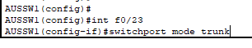

On **AUSSW1 (Switch)**, we are configuring FastEthernet port f0/23 to be a trunk port, so it can carry multiple VLANs (VLAN 70, 80, 90). Make sure connect to router cable is trunk mode.

### 7.2.1 Router 1

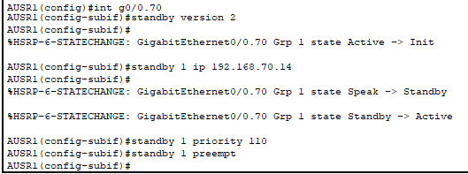



Implement HSRP on interfaces **g0/0.70:**

* *int g0.0/70*

Access to the subinterface for **VLAN 70.**

* *standby version 2*

Here, we use HSRP version 2, which supports more groups and IPv6 compared to version 1.

* *standby 1 ip* ***192.168.70.14***

Assign the **192.168.70.14** as virtual IP address for HSRP group, it will share with **AUSR2 (Router 2)** later.

* *standby 1 priority* ***110***

Set this **AUSR1**’s HSRP priority to 110, giving the higher preference over **AUSR2**, to become the Active Router.

* *standby 1 preempt*

Enable **AUSR1** preemption, it will take over the Active role.

Same goes as above, now we implement HSRP on interface **g0/0.80:**

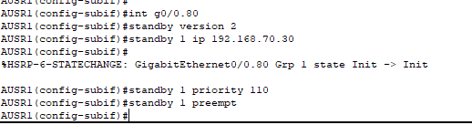

Same goes as above, now we implement HSRP on interface **g0/0.90:**

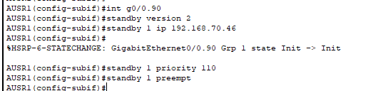

**Summary:**

On **AUSR1**, we configure **HSRP version 2** across **VLANs 70, 80, 90** using subinterface **g0/0.70, g0/0.80, g0/0.90**. Besides, AUSR1 is given the priority of 110 and enabled preemption on all interfaces.

* VLAN 70 🡪 Virtual IP: 192.168.70.14
* VLAN 80 🡪 Virtual IP: 192.168.70.30
* VLAN 90 🡪 Virtual IP: 192.168.70.46

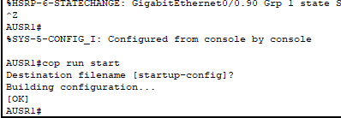



* *copy run start*

Save the current configuration to ensure changes are retained after reboot.

### 7.2.2 Router 2

Now, we are going to configure **AUSR2** as **Standby Router** in each **VLANs 70, 80 and 90.**



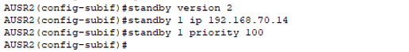

Configure HSRP on interfaces **g0/0.70:s**

* *int g0.0/70*

Access to the subinterface for **VLAN 70.**

* *standby version 2*

Here, we use HSRP version 2, which supports more groups and IPv6 compared to version 1.

* *standby 1 ip* ***192.168.70.14***

Configure the shared **virtual IP** that same as **AUSR1** here.

* *standby 1 priority* ***100***

Set this **AUSR2**’s HSRP priority to 100, **must lower priority than AUSR1**, making it as **Standby Router** unless AUSR1 fails.

Same goes as above, now we configure HSRP on interfaces **g0/0.80:**

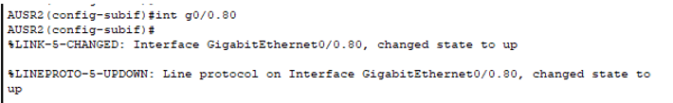

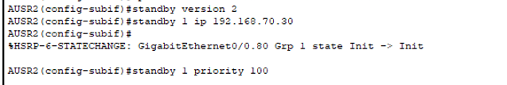

Same goes as above, now we configure HSRP on interfaces **g0/0.90:**

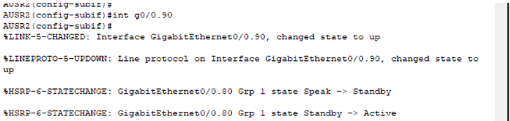

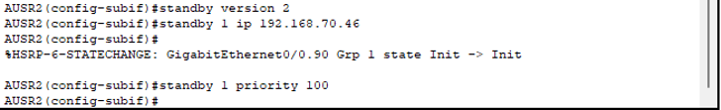

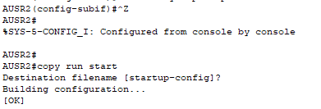



* *copy run start*

Save the current configuration to ensure changes are retained after reboot.

After done all the implementation and configuration for HSRP in **AUSR1** and **AUSR2**, we now going to confirm that our **AUSR1** is successfully acting as **Active Router** and **AUSR2** is acting as **Standby Router.** We use below command confirm the HSRP configuration is fully operational.

* sh standby br

**On AUSR1 (Router 1):**

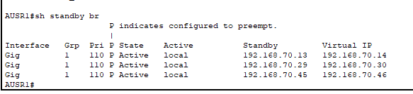

The state of AUSR1 is mark as **Active** and the IP address all correct.

**On AUSR2 (Router 2):**

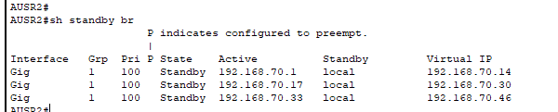

The state of AUSR2 is mark as **Standby** and the IP address all correct.

# 8.0 Server Farm Configuration (SG) – Chong Chia Zhi TP079795

In here will create 3 Server Farm, which is WEB Server and DNS Server and FTP Server.

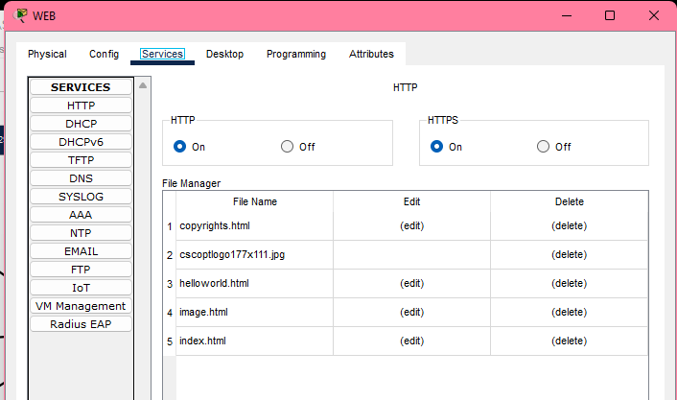

Web Sever

* Go to Config change Display Name to WEB Server.
* Go to Services and make HTTP and HTTPS in On.

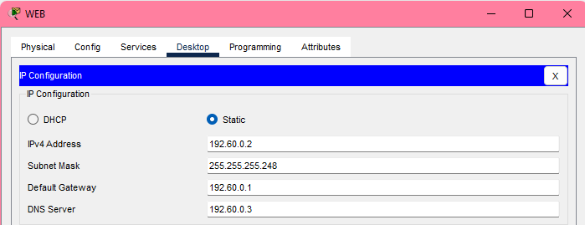

* Go to Desktop click IP Configuration change the IP addresses to 192.168.40.2.

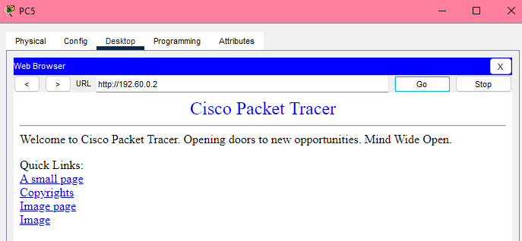

Enter the IP address of Web Server in the browser on the PC and can see that have successfully entered the website.

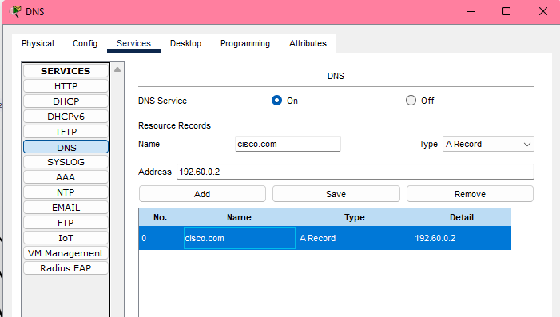

DNS Server

* Go to Config change Display Name to DNS Server,
* Go to Services then go to DNS make DNS Services in On. Then Resource Records Name set to cisco.com (domain name) and set Type in A record. After that, set Address in 192.168.40.2. Lastly, click button “Add” will pop up details.

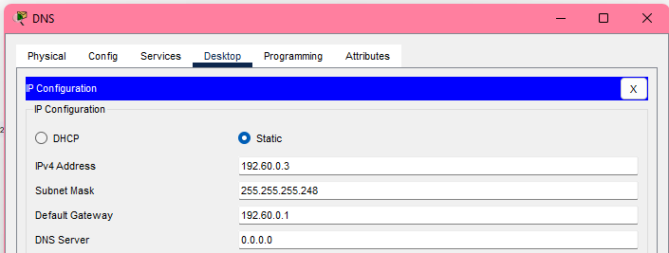

* Go to Desktop click IP Configuration change Ip addresses in 192.168.40.3.

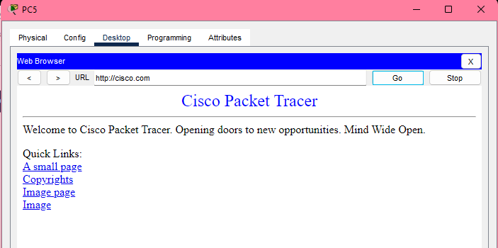

Enter the domain name of Web Server in the browser on the PC and can see that have successfully entered the website.

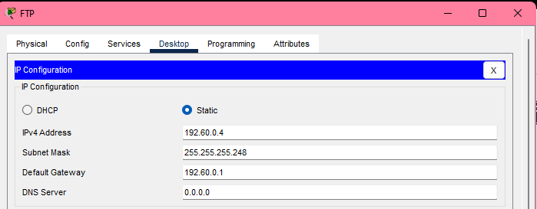

FTP Server

* Go to Config change Display Name to FTP Server.
* Go to Desktop click IP Configuration change the IP addresses to 192.168.40.4.

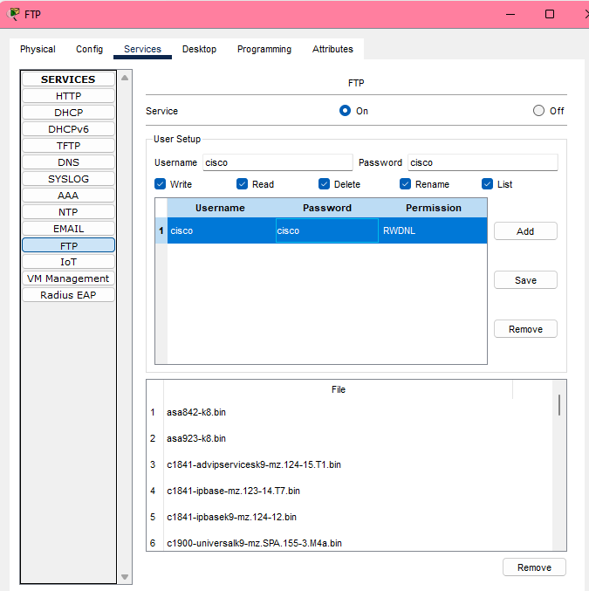

* Go to Service click FTP make Service in On. Then in User Setup add Username is cisco and Password is cisco. Lastly click button “Add” below will pop up details that create on User Setup.

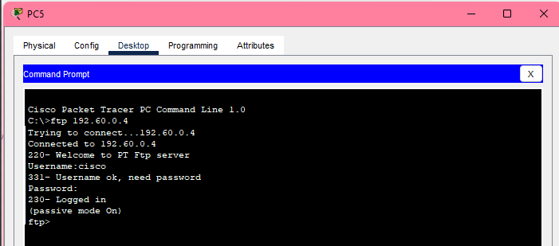

Type ‘ftp 192.60.0.4’ on the command prompt of the PC and enter the account and password. If 'logged in' appears, it means that the FTP server is successfully connected.

# 9.0 Evidence of a successful ping of the network interconnect

KL VLAN 10 Device to KL VLAN 20 Device

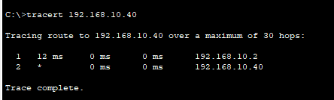

KL VLAN 10 Device to KL VLAN 30 Device

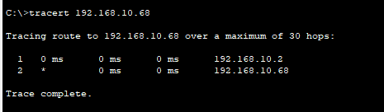

KL VLAN 10 Device to SG VLAN 40 Device

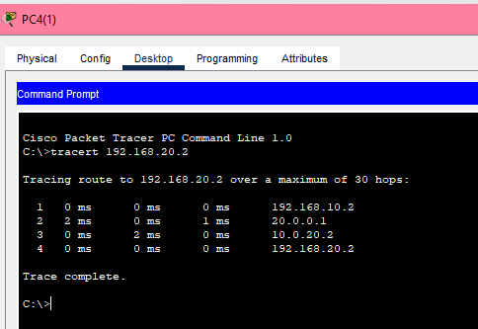

KL VLAN 10 Device to SG VLAN 50 Device

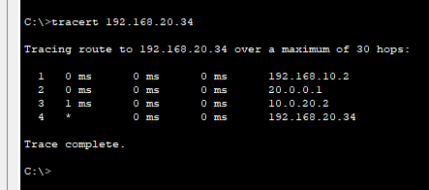

From KL VLAN 30 Device Ping to SG VLAN 50 Device

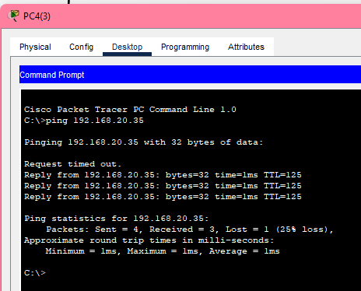

KL VLAN 10 Device to SG VLAN 60 ServerFarm

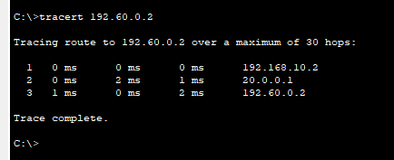

SG VLAN 40 Device to SG VLAN 60 ServerFarm

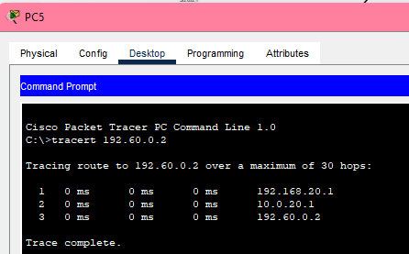

AUS VLAN 70 Device to SG VLAN 60 ServerFarm

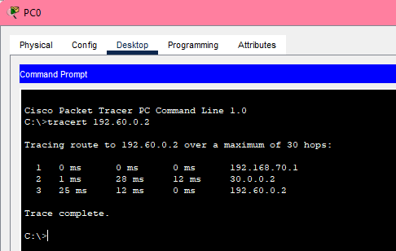

KL VLAN 10 Device to AUS VLAN 70 Access Point

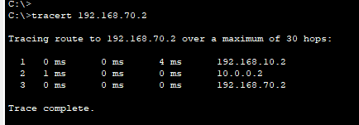

KL VLAN 10 Device to AUS VLAN 80 Access Point

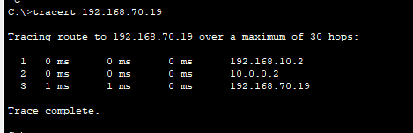

KL VLAN 10 Device to AUS VLAN 90 Access Point

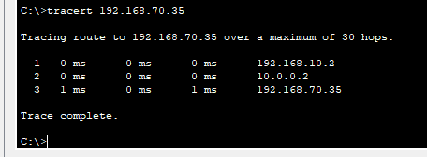

# 10.0 Security Mechanisms Deployment – Lim Hao Zhen TP079000

## 10.1 Port Security

Port Security is used to mitigate MAC address flooding and MAC address spoofing attacks. For example, MAC address flooding is when an attacker uses a fake MAC address to send flood information to the switch, causing the CAM table to overflow and the switch to act as a hub to flood all traffic. MAC address spoofing is when an attacker configures the network card of another legitimate device with its MAC address to hijack its identity.

### 10.1.1 KL

#### 10.1.1.1 KLSW1

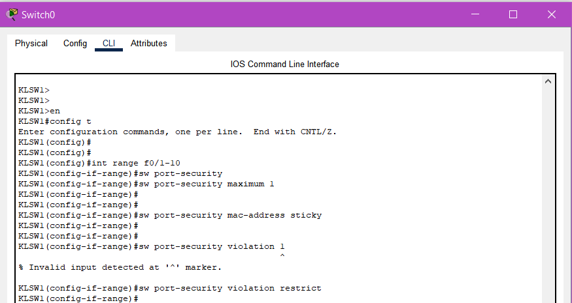



* *int range f0/10-10*

Select the port clients interface.

* *switchport port-security maximum 1*

Provide maximum number of MAC address.

* *switchport port-security mac-address sticky*

Configure MAC address to sticky.

* *switchport port-security violation restrict*

Set the violation to restrict mode.

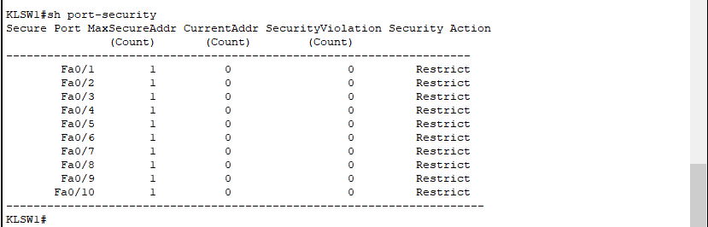

* *sh port-security*

Show the port-security.

#### 10.1.1.2 KLSW2 Same configuration as above KLSW1:

Implement port security:

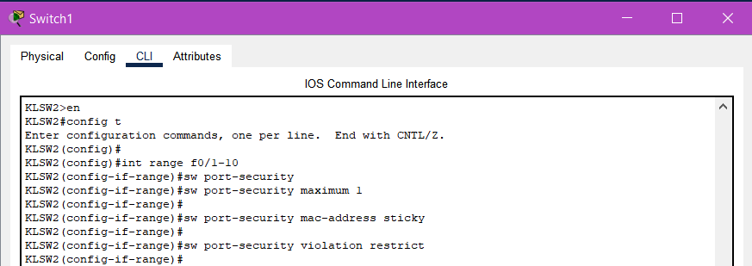

Show port security:

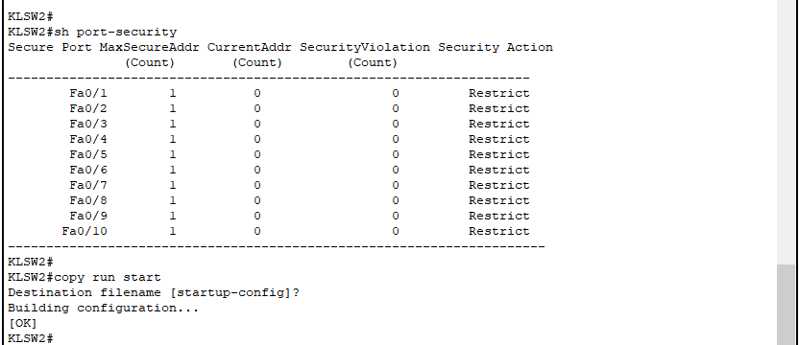

#### 10.1.1.3 KLSW3

Same configuration as above:

Implement port security:

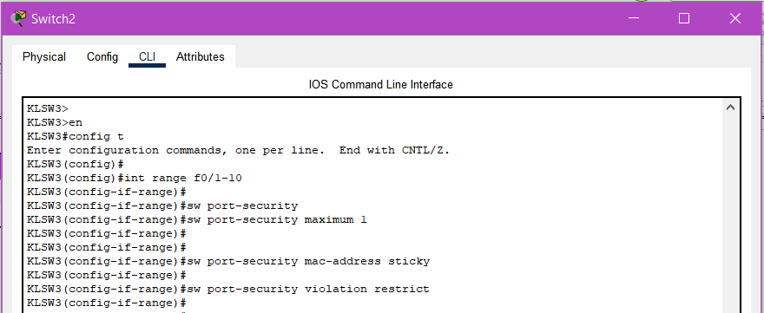

Show port security:

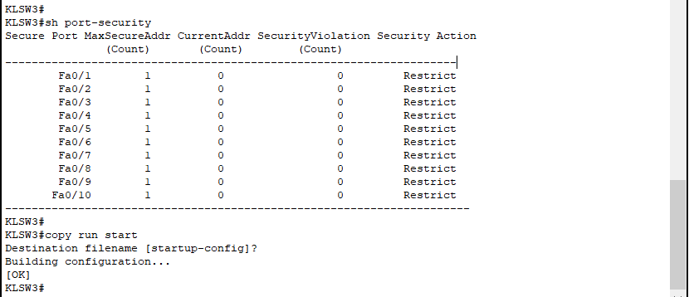

### 10.1.2 AUS

In Australia, same configuration as KL, but change the interface port clients.

Implement port security:

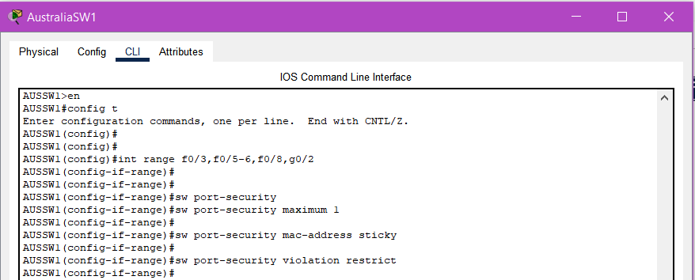

Show port security:

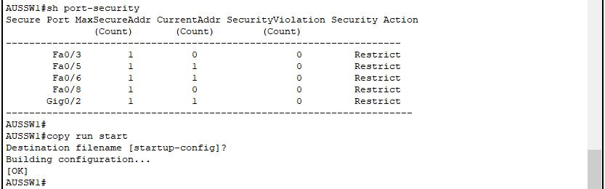

### 10.1.3 SG

#### 10.1.3.1 SGSW1 (Multilayer Switch)

In Singapore, same configuration as KL/AUS, but change the interface port clients.

Implement port security:

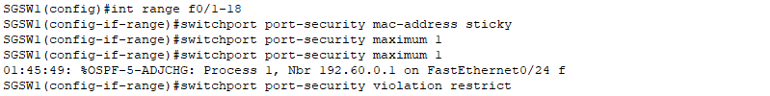

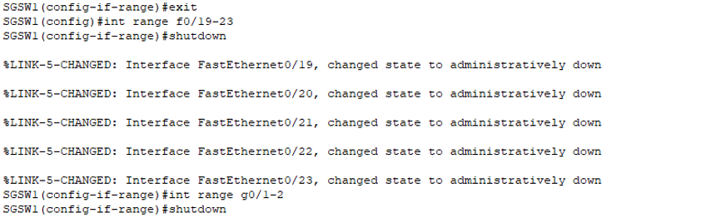

Show port security:

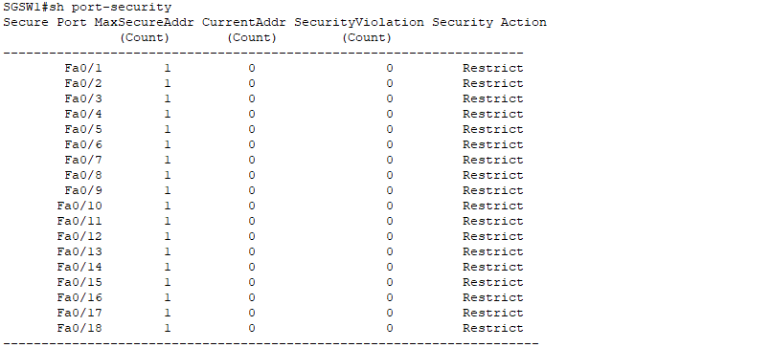

#### 10.1.3.2 SGSW2 (Layer 2 Switch)

In Singapore, same configuration as KL/AUS, but change the interface port clients.

Implement port security:

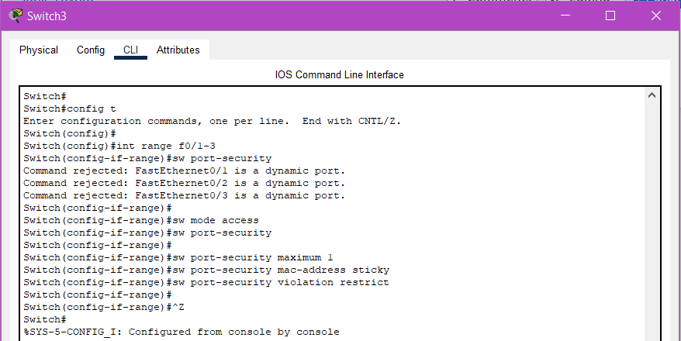

Show port security:

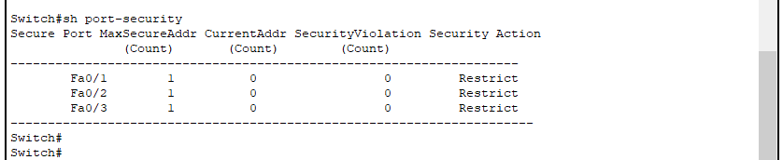

## 10.2 DHCP Snooping

DHCP Snooping is used to mitigate DHCP starvation and DHCP spoofing attacks. For example, an attacker sends many DHCP requests to exhaust the resource pool.

### 10.2.1 AUS

Implement DHCP Snooping at Australia, since all IP address of devices is DHCP instead of Static:

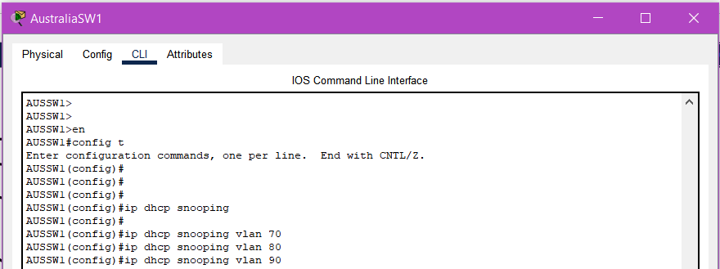

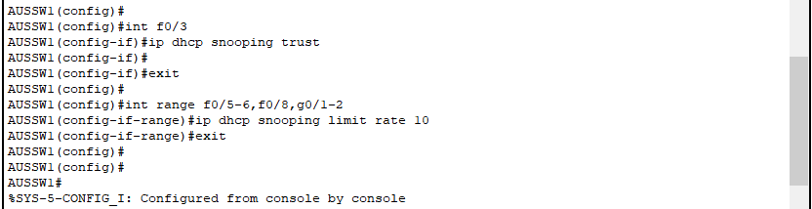

* *en 🡪 config t*
* *ip dhcp snooping vlan 70*
* *ip dhcp snooping vlan 80*
* *ip dhcp snooping vlan 90*
* *int f0/3*

This interface is the uplink to DHCP server.

* *ip dhcp snooping trust*

Set uplink router port to be trusted.

* *exit*
* *int range f0/5-6,f0/8,g0/1-2*

This interface is the client port.

* *ip dhcp snooping limit rate 10*

*C*onfiguring a **rate limit** on client port.

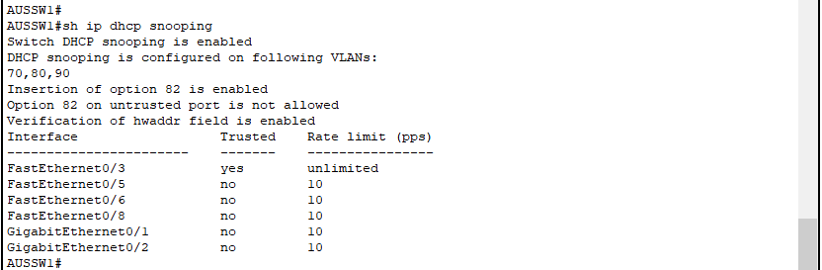

* *sh ip dhcp snooping*

Show the dhcp snooping.

## 10.3 Dynamic ARP Inspection (DAI)

Dynamic ARP Inspection (DAI) is used to mitigate ARP spoofing and poisoning. For example, attackers may pretend to be a gateway or other host, causing data to be stolen.

### 10.3.1 KL

#### 10.3.1.1 KLSW1

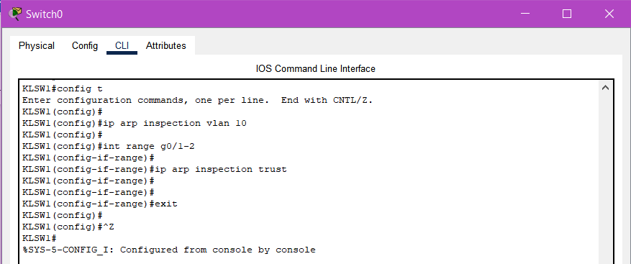

* *ip arp inspection vlan 10*

Enable DAI on VLANs with DHCP clients

* *int range g0/1-2*

This interface is uplink ports to router

* *ip inspection trust*

Trust the uplink ports.

* *exit*

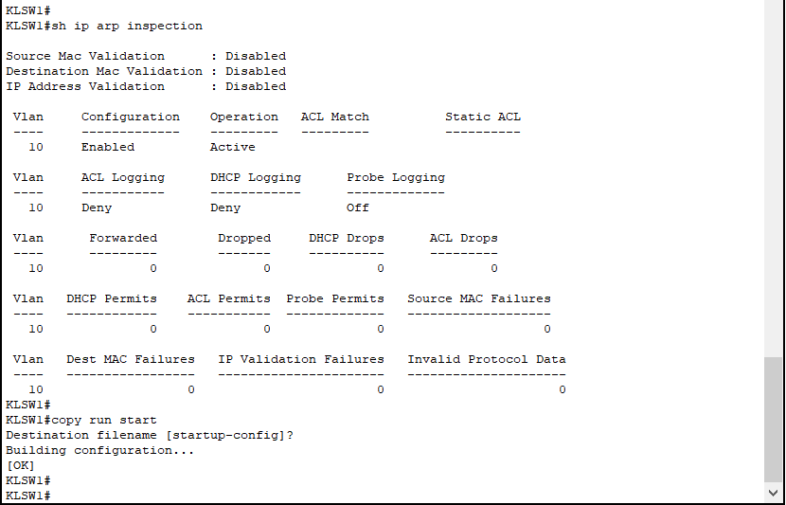

* *sh ip arp inspection*

Verification ARP inspection.

#### 10.3.1.2. KLSW2

Same configuration as above KLSW1:

Implement DAI:

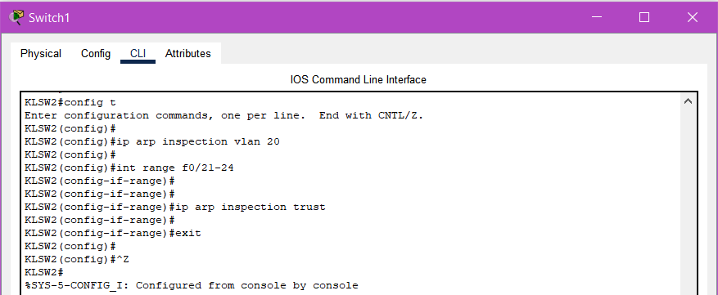

Verification DAI:

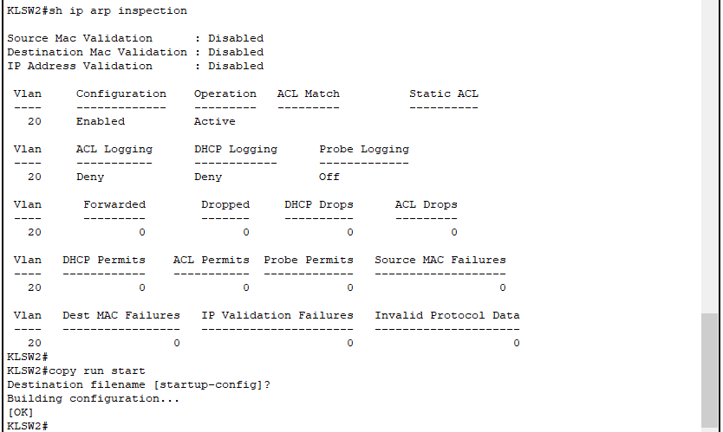

#### 10.3.1.3 KLSW3

Same configuration as above KLSW1:

Implement DAI:

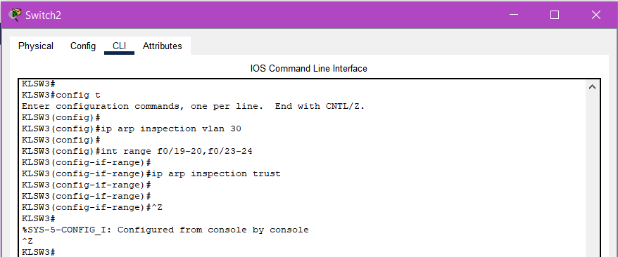

Verification DAI:

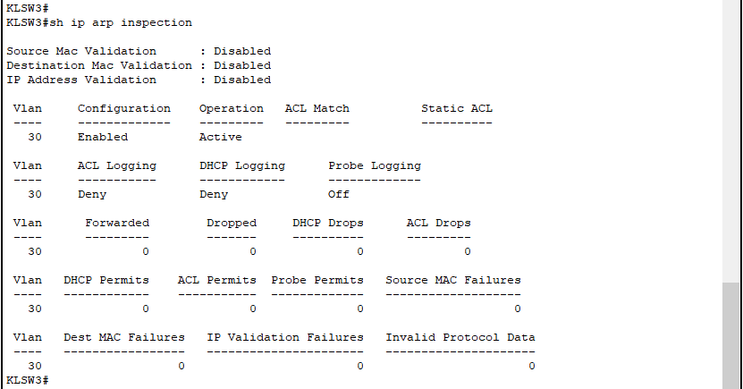

### 10.3.2 AUS

In Australia, same configuration as KL, but change the interface port clients and VLANs.

Implement DAI:

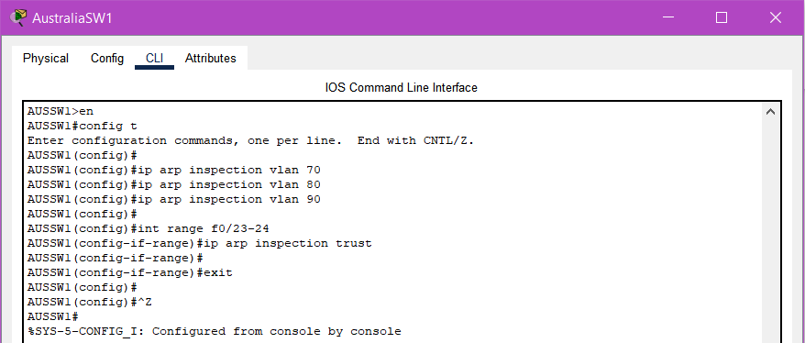

Verification DAI:

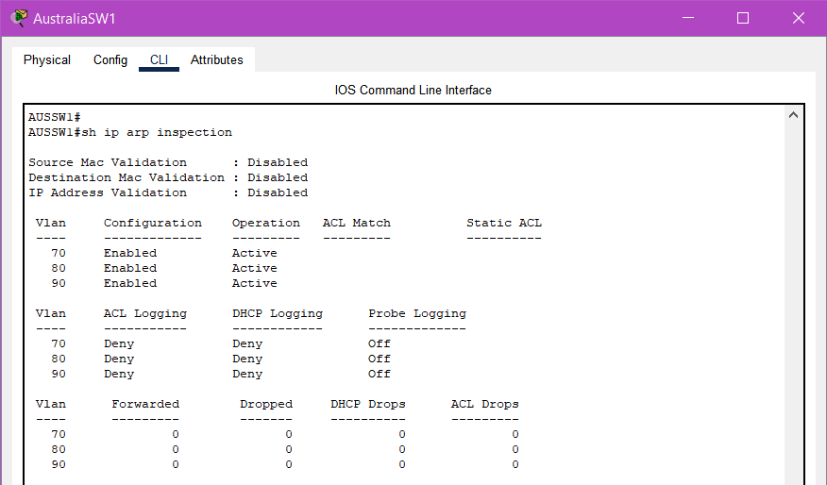

## 10.4 PortFast/BPDU Guard

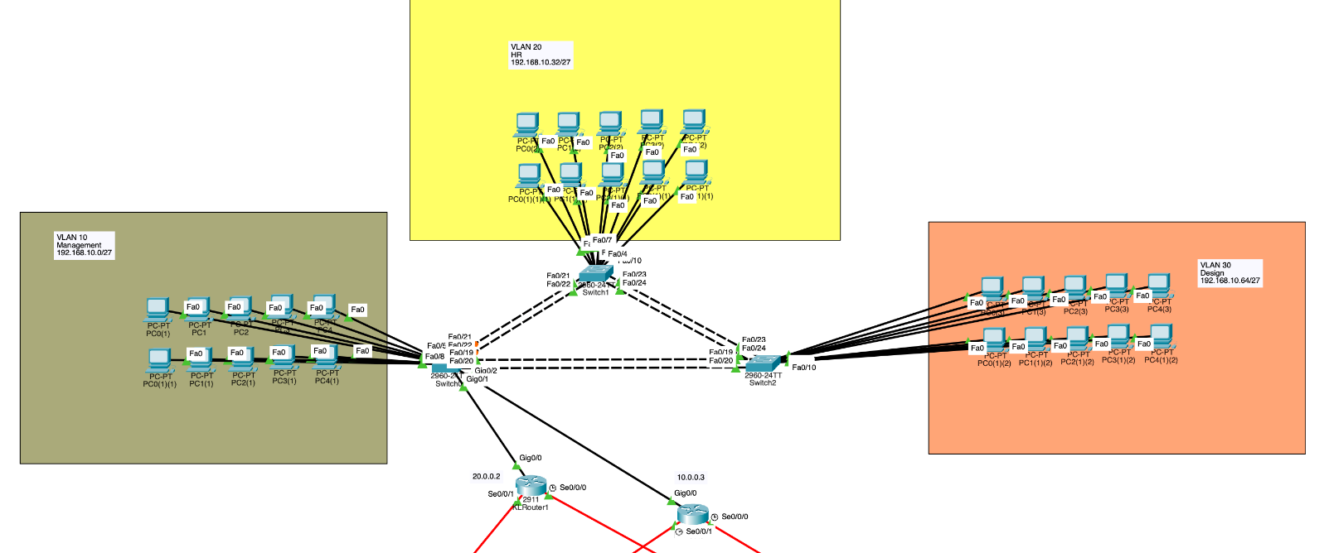

PortFast and Bridge Protocol Data Unit (BPDU) Guard are among the mitigations for Spanning Tree Protocol (STP) manipulation attacks. PortFast immediately puts the port into a forwarding state and bypasses STP learning/listening, speeding up the access port and preparing it for use with BPDU Guard. BPDU Guard monitors BPDUs on PortFast ports. If any BPDUs are received, the port is immediately shut down to block a rogue switch.

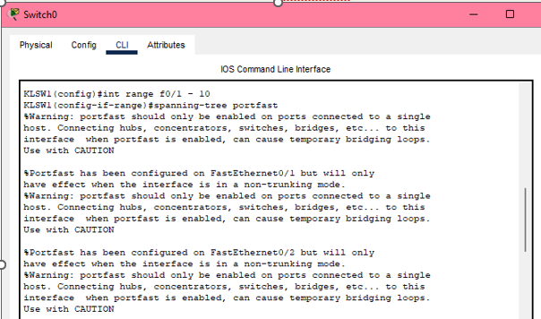

* *int range f0/1-10*
* *spanning-tree portfast*

Configure portfast for all end devices connected to the switch.

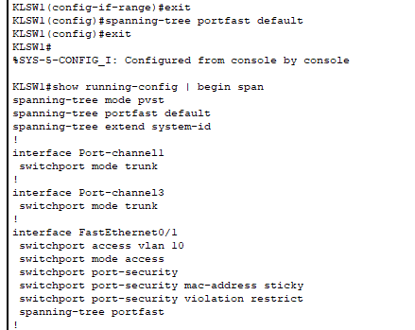

* *spanning-tree portfast default*
* *show running-config | begin span*

Check that portfast is configured on the interface

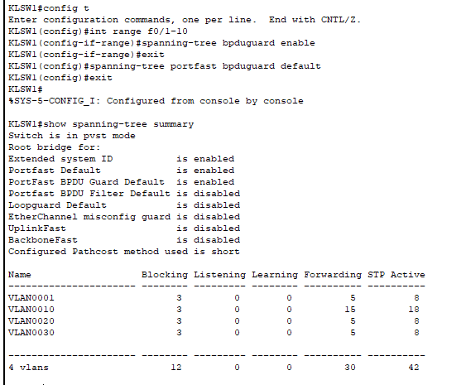

* *int range f0/1-10*
* *spanning-tree bpduguard enable*
* *spanning-tree portfast bpduguard default*

Configure the bpduguard to all end device

* *show spanning-tree summary*

Check that BPDU Guard and Portfast is enabled.

**The same configuration is also used on other KL switches.**

## 10.5 Overall Summary

**Security Mechanisms Deployment to mitigate the attacks:**

* **Port Security**

Prevents many types of attacks including MAC address flooding attacks and DHCP starvation attacks. **(Mac Table Attacks)**

* **DHCP Snooping**

Prevents DHCP starvation and DHCP spoofing attacks. **(DHCP Attacks)**

* **Dynamic ARP Inspection (DAI)**

Prevents ARP spoofing and ARP poisoning attacks. **(ARP Attacks)**

* **PortFast/BPDU Guard**

Prevents Layer 2 switching loops and mitigates Spanning Tree Protocol manipulation attacks. **(STP Attacks)**

# 11.0 Recommendation for improving security mechanisms - Voon Yue Cheng TP080509

Despite using port security to mitigate layer 2 attacks, the network is still vulnerable to other attacks. To enhance the overall security to the network, the following additional security mechanisms can be implemented:

* **Firewall:** Deploying a firewall between internal network connections and external network connections can be effective for network security. Firewall can filter and inspect incoming and outgoing network traffic. It helps to block unauthorized access to the network and detect suspicious activity, and effectively prevents attacks like malware, denial of service (DoS) attacks, and other external network intrusion.
* **Centralized Logging and Monitoring:** Deploying syslog and simple network management protocol (SNMP) enables administrators to monitor real-time user activities and manage network activities. This allows early detection on cyber-attacks and facilitate rapid response to mitigate the loss.
* **Access Control List (ACL):** Configuring ACLs on routers and layer 3 switches enables the control of network traffic flow between VLANs. Like firewall, ACLs operate in internal network to filter network traffic based on the IP address, port numbers, or protocols. This reduces the risk of lateral movement attacks. For example, if an unauthorized user gained access to an initial device in the network, ACLs prevent the user from gaining access to every other device in the network.

By implementing these additional security mechanisms, the network can be more secure, significantly minimizing the risks and potential impacts of cyber-attacks.

# 12.0 Conclusion

In conclusion, the network design and configuration designed for Cloud Co demonstrates a comprehensive approach to modern networking. This report outlines the design and configuration of a secure and reliable network successfully designed for Cloud Co, covering all three branches: Kuala Lumpur (KL), Australia (Aus) and Singapore (SG).

The technologies and techniques implemented in this assignment include WLC WLAN with VLAN interface, DHCP, and WPA2 authentication; IPv4 addressing using both static and dynamic routes by implementing OSPF and default static route; port security for Layer 2 protection; and HSRP and EtherChannel for redundancy and load balancing. These technologies and techniques ensure the networks reliability, flexibility, and security.

Overall, this assignment provides the valuable knowledge and skills in designing and configuring a secure and reliable network using industry-standard technologies and techniques shown above. The knowledge and skills gained can be beneficial for the future real-world networking scenarios.

（5400++ words）

# 13.0 References

ASM Educational Center. (2021, October 22). *Layer 2 attacks*. <https://asmed.com/layer-2-attacks/>

CrowdSec. (2025, March 14). *What is port security? | CrowdSec*. <https://www.crowdsec.net/glossary/port-security>

Barracuda. (2024, November 18). *What is a network firewall?* Barracuda Networks. <https://www.barracuda.com/support/glossary/network-firewall?utm_source=chatgpt.com>

*Centralized Logging & Centralized Log Management (CLM) | SpLUNK*. (n.d.-b). Splunk. <https://www.splunk.com/en_us/blog/learn/centralized-logging.html?utm_source=chatgpt.com>

*What is a Network Access Control List (ACL)? | Fortinet*. (n.d.). Fortinet. <https://www.fortinet.com/resources/cyberglossary/network-access-control-list?utm_source=chatgpt.com>

GeeksforGeeks. (2025b, May 22). *Types of Spanning Tree Protocol (STP)*. GeeksforGeeks. <https://www.geeksforgeeks.org/types-of-spanning-tree-protocol-stp/>

Cisco. (2018). *Catalyst 4500 series switch Cisco IOS software configuration guide, 12.2(25)EW -understanding and configuring dynamic ARP inspection [Cisco catalyst 4500 series Switches]*. Cisco. <https://www.cisco.com/c/en/us/td/docs/switches/lan/catalyst4500/12-2/25ew/configuration/guide/conf/dynarp.html>

*Security - Configuring IP Source Guard   [Cisco Catalyst 3850 Series Switches]*. (n.d.). Cisco. <https://www.cisco.com/en/US/docs/switches/lan/catalyst3850/software/release/3.2_0_se/multibook/configuration_guide/b_consolidated_config_guide_3850_chapter_0110110.html>

*Configuring DHCP Snooping About DHCP Snooping*. (n.d.). <https://www.cisco.com/c/en/us/td/docs/dcn/nx-os/nexus3548/103x/configuration/security/cisco-nexus-3548-nx-os-security-configuration-guide-103x/m-configuring-dhcp-snooping.pdf>

*Spanning Tree Protocol (STP) Configuration*. (n.d.). Grandmetric. <https://www.grandmetric.com/knowledge-base/design_and_configure/spanning-tree-protocol-stp-configuration/>